EXERCISES ON MICROSOFT EXCEL

EXERCISE 1

Move Around the Worksheet

The Down Arrow Key
- Press the down arrow key several times. Note that the cursor moves downward one cell at a time.
The Up Arrow Key
- Press the up arrow key several times. Note that the cursor moves upward one cell at a time.
The Tab Key
- Move to cell A1.
- Press the Tab key several times. Note that the cursor moves to the right one cell at a time.
The Shift + Tab Keys
- Hold down the Shift key and then press Tab. Note that the cursor moves to the left one cell at a time.
The Right and Left Arrow Keys
- Press the right arrow key several times. Note that the cursor moves to the right.
- Press the left arrow key several times. Note that the cursor moves to the left.
Page Up and Page Down
- Press the Page Down key. Note that the cursor moves down one page.
- Press the Page Up key. Note that the cursor moves up one page.
The Ctrl-Home Key
- Move the cursor to column J.
- Stay in column J and move the cursor to row 20.
- Hold down the Ctrl key while you press the Home key. Excel moves to cell A1.
EXERCISE 2

Select Cells
To select cells A1 to E1:
- Go to cell A1.
- Press the F8 key. This anchors the cursor.
- Note that "Extend Selection" appears on the Status bar in the lower-left corner of the window. You are in the Extend mode.
- Click in cell E7. Excel highlights cells A1 to E7.
- Press Esc and click anywhere on the worksheet to clear the highlighting.
EXERCISE 3

Enter Data
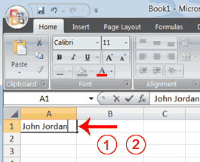
- Place the cursor in cell A1.
- Type John Jordan. Do not press Enter at this time.
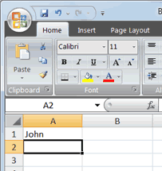

Delete Data
The Backspace key erases one character at a time.
- Press the Backspace key until Jordan is erased.
- Press Enter. The name "John" appears in cell A1.
EXERCISE 4

Addition
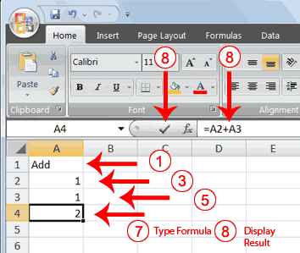
- Type Add in cell A1.
- Press Enter. Excel moves down one cell.
- Type 1 in cell A2.
- Press Enter. Excel moves down one cell.
- Type 1 in cell A3.
- Press Enter. Excel moves down one cell.
- Type =A2+A3 in cell A4.
- Click the check mark on the Formula bar. Excel adds cell A1 to cell A2 and displays the result in cell A4. The formula displays on the Formula bar.
Note: Clicking the check mark on the Formula bar is similar to pressing Enter. Excel records your entry but does not move to the next cell.

Subtraction
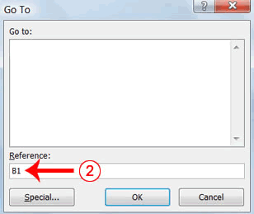
- Press F5. The Go To dialog box appears.
- Type B1 in the Reference field.
- Press Enter. Excel moves to cell B1.
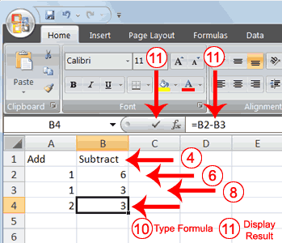
- Type Subtract.
- Press Enter. Excel moves down one cell.
- Type 6 in cell B2.
- Press Enter. Excel moves down one cell.
- Type 3 in cell B3.
- Press Enter. Excel moves down one cell.
- Type =B2-B3 in cell B4.
- Click the check mark on the Formula bar. Excel subtracts cell B3 from cell B2 and the result displays in cell B4. The formula displays on the Formula bar.
Multiplication
- Hold down the Ctrl key while you press "g" (Ctrl+g). The Go To dialog box appears.
- Type C1 in the Reference field.
- Press Enter. Excel moves to cell C1
- Type Multiply.
- Press Enter. Excel moves down one cell.
- Type 2 in cell C2.
- Press Enter. Excel moves down one cell.
- Type 3 in cell C3.
- Press Enter. Excel moves down one cell.
- Type =C2*C3 in cell C4.
- Click the check mark on the Formula bar. Excel multiplies C1 by cell C2 and displays the result in cell C3. The formula displays on the Formula bar.
Division
- Press F5.
- Type D1 in the Reference field.
- Press Enter. Excel moves to cell D1.
- Type Divide.
- Press Enter. Excel moves down one cell.
- Type 6 in cell D2.
- Press Enter. Excel moves down one cell.
- Type 3 in cell D3.
- Press Enter. Excel moves down one cell.
- Type =D2/D3 in cell D4.
- Click the check mark on the Formula bar. Excel divides cell D2 by cell D3 and displays the result in cell D4. The formula displays on the Formula bar.
When creating formulas, you can reference cells and include numbers. All of the following formulas are valid:
=A2/B2
=A1+12-B3
=A2*B2+12
=24+53
AutoSum
You can use the AutoSum button on the Home tab to automatically add a column or row of numbers. When you press the AutoSum button , Excel selects the numbers it thinks you want to add. If you then click the check mark on the Formula bar or press the Enter key, Excel adds the numbers. If Excel's guess as to which numbers you want to add is wrong, you can select the cells you want.
EXERCISE 5

AutoSum
The following illustrates AutoSum:
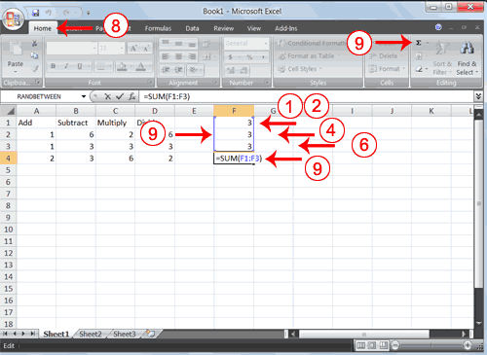
- Go to cell F1.
- Type 3.
- Press Enter. Excel moves down one cell.
- Type 3.
- Press Enter. Excel moves down one cell.
- Type 3.
- Press Enter. Excel moves down one cell to cell F4.
- Choose the Home tab.
- Click the AutoSum button in the Editing group. Excel selects cells F1 through F3 and enters a formula in cell F4.
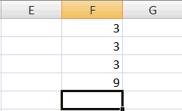
- Press Enter. Excel adds cells F1 through F3 and displays the result in cell F4.
Perform Automatic Calculations
By default, Microsoft Excel recalculates the worksheet as you change cell entries. This makes it easy for you to correct mistakes and analyze a variety of scenarios.
EXERCISE 6

Automatic Calculation
Make the changes described below and note how Microsoft Excel automatically recalculates.
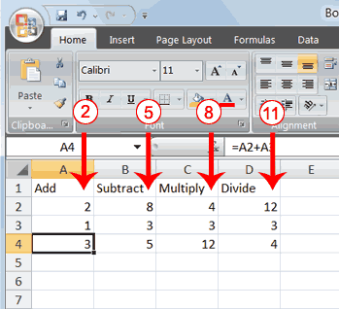
- Move to cell A2.
- Type 2.
- Press the right arrow key. Excel changes the result in cell A4. Excel adds cell A2 to cell A3 and the new result appears in cell A4.
- Move to cell B2.
- Type 8.
- Press the right arrow key. Excel subtracts cell B3 from cell B3 and the new result appears in cell B4.
- Move to cell C2.
- Type 4.
- Press the right arrow key. Excel multiplies cell C2 by cell C3 and the new result appears in cell C4.
- Move to cell D2.
- Type 12.
- Press the Enter key. Excel divides cell D2 by cell D3 and the new result appears in cell D4.
Align Cell Entries
When you type text into a cell, by default your entry aligns with the left side of the cell. When you type numbers into a cell, by default your entry aligns with the right side of the cell. You can change the cell alignment. You can center, left-align, or right-align any cell entry. Look at cells A1 to D1. Note that they are aligned with the left side of the cell.
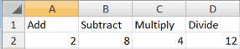
EXERCISE 7

Center
To center cells A1 to D1:
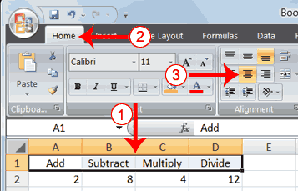
- Select cells A1 to D1.
- Choose the Home tab.
- Click the Center button in the Alignment group. Excel centers each cell's content.
Left-Align
To left-align cells A1 to D1:
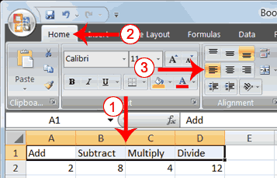
- Select cells A1 to D1.
- Choose the Home tab.
- Click the Align Text Left button in the Alignment group. Excel left-aligns each cell's content.
Right-Align
To right-align cells A1 to D1:
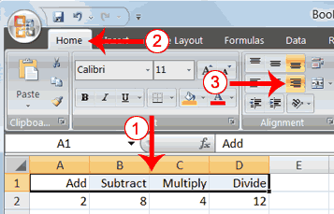
- Select cells A1 to D1. Click in cell A1.
- Choose the Home tab.
- Click the Align Text Right button. Excel right-aligns the cell's content.
- Click anywhere on your worksheet to clear the highlighting.
Note: You can also change the alignment of cells with numbers in them by using the alignment buttons.
Perform Advanced Mathematical Calculations
When you perform mathematical calculations in Excel, be careful of precedence. Calculations are performed from left to right, with multiplication and division performed before addition and subtraction.
EXERCISE 8

Advanced Calculations
- Move to cell A7.
- Type =3+3+12/2*4.
- Press Enter.
Note: Microsoft Excel divides 12 by 2, multiplies the answer by 4, adds 3, and then adds another 3. The answer, 30, displays in cell A7.
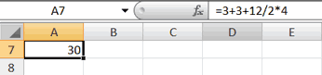
To change the order of calculation, use parentheses. Microsoft Excel calculates the information in parentheses first.
- Double-click in cell A7.
- Edit the cell to read =(3+3+12)/2*4.
- Press Enter.
Note: Microsoft Excel adds 3 plus 3 plus 12, divides the answer by 2, and then multiplies the result by 4. The answer, 36, displays in cell A7.
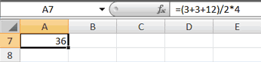

EXERCISE 9

Copy, Cut, Paste, and Cell Addressing
- Move to cell A9.
- Type 1. Press Enter. Excel moves down one cell.
- Type 1. Press Enter. Excel moves down one cell.
- Type 1. Press Enter. Excel moves down one cell.
- Move to cell B9.
- Type 2. Press Enter. Excel moves down one cell.
- Type 2. Press Enter. Excel moves down one cell.
- Type 2. Press Enter. Excel moves down one cell.
In addition to typing a formula as you did before, you can also enter formulas by using Point mode. When you are in Point mode, you can enter a formula either by clicking on a cell or by using the arrow keys.
- Move to cell A12.
- Type =.
- Use the up arrow key to move to cell A9.
- Type +.
- Use the up arrow key to move to cell A10.
- Type +.
- Use the up arrow key to move to cell A11.
- Click the check mark on the Formula bar. Look at the Formula bar. Note that the formula you entered is displayed there.
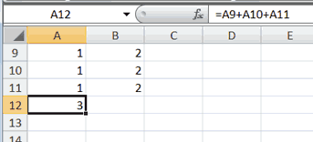
Copy with the Ribbon
To copy the formula you just entered, follow these steps:
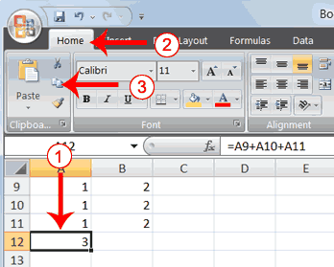
- You should be in cell A12.
- Choose the Home tab.
- Click the Copy button in the Clipboard group. Excel copies the formula in cell A12.
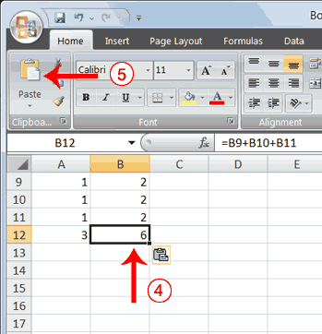
- Press the right arrow key once to move to cell B12.
- Click the Paste button in the Clipboard group. Excel pastes the formula in cell A12 into cell B12.
- Press the Esc key to exit the Copy mode.
Compare the formula in cell A12 with the formula in cell B12 (while in the respective cell, look at the Formula bar). The formulas are the same except that the formula in cell A12 sums the entries in column A and the formula in cell B12 sums the entries in column B. The formula was copied in a relative fashion.
Before proceeding with the next part of the exercise, you must copy the information in cells A7 to B9 to cells C7 to D9. This time you will copy by using the Mini toolbar.

EXERCISE 10

The SUM Function in Excel 2007
In earlier parts of this course, you used addition formula quite a lot. You saw that the basic way to add things up was by doing this:
=A1 + B1 + C1
You've also used the in-built SUM function:
=SUM(A1:C1)
Whichever of these two you used, the answer was the same - Excel will add up whatever numbers you have in the cells A1, B1, and C1. The two methods above are adding up consecutive cells. But what if you want to add up the following, non-consecutive cells: A1, B1, C1, D9?
Well, you can combine the two methods. So you can do it like this:
= Sum(A1:C1) + D9
or you can do it like this:
= Sum(A1:C1, D9)
For the first method, just type a plus sign after your SUM function, followed by the cell you want to include:
= Sum(A1:C1) + D9
You can include as many other cells as you like:
= Sum(A1:C1) + D9 + E12 + G25
You can even use another SUM function:
= Sum(A1:C1) + SUM(G1:H1)
But you are just telling Excel which cells in your spreadsheet that you want to include in your addition formula.
The second method to add up non-consecutive cells starts in the same way: use a SUM function, and separate your consecutive cells with a colon:
= Sum(A1:C1)
To include the non consecutive cells, type a comma, followed by the cell you want to include:
= Sum(A1:C1, D9)
You can include other cells, as well:
= Sum(A1:C1, D9, E12, G25)
The thing to note is that all the cells are between the round brackets of the SUM function. Excel knows that SUM means to add up, so it sees each cell reference separated by commas, and then includes them in the addition.
To give you some practice, try this exercise.

Exercise 11
Create a simple spreadsheet with the number 3 in cells A1, B1, C1 and D1. Enter another number 3 in cell A2. Use one of the non consecutive addition formula above to add up the values in all five cells. Your spreadsheet will then look like this, once you have the correct formula:
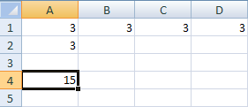
In the picture above, cell A4 displays the correct answer.
Selecting Non Consecutive Cells
Another way to select non-consecutive cells for your SUM functions is by holding down the CTRL key on your keyboard, and then left click in the cell you want to add. Try this:
- Click inside a different cell in your spreadsheet (B4, for example). Then click inside the formula bar at the top
- Now type the following into the formula bar (Don't forget to add the colon at the end):
=SUM(A1:
- The cell A1 will be highlighted on the spreadsheet. It will have sizing handles, so that you can stretch the selection
- Hold your left mouse button over the bottom right blue square, and drag to cell D1. You spreadsheet should look like this:
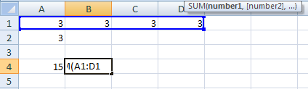
Excel will add the cells to your formula. But it will also add a colon after D2. We don't want this, because a colon means "add up a range of cells". So delete the colon and type a comma instead.
Now that you have the cells A1 to D1 selected, hold down the left CTRL key on your keyboard. Keep it held down, and click inside cell A2 with your left mouse button:
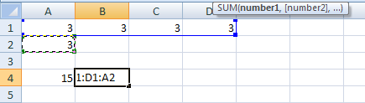
The cell A2 is highlighted, in the image above. Excel will add this to your formula.. To finish off, add the right bracket ). Then press the enter key on your keyboard.
Using this method, you can add as many individual cells as you want for your formula.
Exercise 12
On a new sheet, enter the number 3 in the following cells: A1, B1, C1, D1, E1. Then type a 3 in the cells A3, C3 and E3. Using non-consecutive addition, display your answer in cell A5. The finished spreadsheet will then look like ours below:
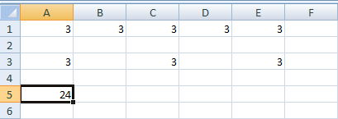
The answer to the addition, 24, is displayed in A5. Only one Sum function was used here, with the other cells separated by commas.
Adding up shouldn't cause you too many problems. The tricky part is selecting all the cells that you want to include. In the next part, we'll at multiplication.
EXERCISE 13

13.1 Create in Excel the worksheet shown below:

OPEN LATE CAFÉ & CO

SALES REPORT IN RWF

Region | January | February
North | 10,11,000 | 13,400,000
South | 22,100,000 | 20,050,000
East | 13,270,000 | 15,670,000
West | 10,800,000 | 21,500,000

13.2 Add a column which totals the sales in January & February

13.3 Using the OPEN LATE CAFÉ & CO sales report create the percentage change column. Percentage change is given by $\frac{\text{February}−\text{January}}{\text{January}}×\text{100}$
13.4 Plot the graph showing the sales report of the OPEN LATE CAFÉ & CO with the following indications:
  - Title: SALES REPORT
  - Horizontal axis: REGION
  - Vertical axis: AMOUNT IN RWF

EXERCISE 14

The ABC Company Ltd, has eight employees (see chart on the next page). You have been asked to develop a spreadsheet that will calculate the total payment for Revenue Canada. The employees do not receive their entire gross pay because the company is required to hold back each employee’s amounts for Canada Pension Plan (CPP), Employment Insurance (EI) and Income Tax, and submit these amounts to Revenue Canada. In addition to the deductions submitted on behalf of its employees, the company must also pay to Revenue Canada an amount equal to what the employees pay for CPP and an amount 1.4 times what the employees pay for EI.
  - Prepare a report identical to the next page. Include the completed table showing all totals.
The formulas for the incomplete columns of the table are:

Employee Net Pay = Gross Pay less the three employee deductions
Employer CPP = Employee CPP
Employer EI = Employee EI times 1.4

Revenue Canada = the three employee deductions plus the two employer contributions

  - Print a copy of your report formulas on one page [use the CTRL + (above the Tab) to display].
  - Save as C:\Excel Assessment.

PAYROLL LEDGER

ABC Company, June 30

 | Employee | Gross | Employee | Employee |  | Employee | Employee | Employer | Employer | Employee
 | Name | Pay | CPP |  | EI | Income Tax | Net Pay | CPP | EI | Name
1 | Malloy, Dawn | 789.25 | 16.30 |  | 23.68 | 98.70
2 | McCullough, Carol | 1,234.55 | 27.43 |  | 37.04 | 225.00
3 | Smith, Doug | 322.55 | 4.64 |  | 9.69 | 6.80
4 | Lafontaine, Bob | 1,732.88 | 39.99 |  | 48.42 | 351.65
5 | Knight, Bonnie | 1,400.00 | 31.49 |  | 42.00 | 269.45
6 | McIssac,Gerry | 1,645.00 | 37.74 |  | 48.42 | 349.70
7 | Macauley, Ian | 895.00 | 18.94 |  | 26.85 | 89.70
8 | Joseph, Roger | 2,495.00 | 58.99 |  | 48.42 | 614.85
 | TOTALS

ECERCISE 15

Enter the data into the following table and then perform the following tasks.

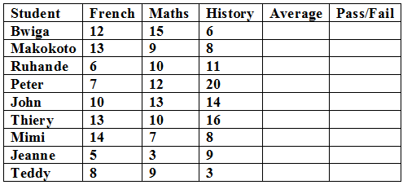

- Find the average of each student
- Make sure that the first row remains stationary (Freeze pane)
The average for each student should be greater than or equal to 10.5 to make student “pass” otherwise “fail”

ECERCISE 16

A. Use formula to find the summation of the students in the following table. However use function to find the average in the same table.

No. | Names | IT/20 | Programming/20 | Visual basic/20 | Sum/60 | Average | Grade
1 | Kaka | 13 | 7 | 16
2 | Rona | 19 | 10 | 2
3 | Eto | 15 | 11 | 13
4 | Diego | 4 | 12 | 17
5 | Drogba | 17 | 5 | 2

B. Use IF function to find students’ grade basing on the criteria below:
16 – 20 = “Grande distinction”
13 – 15.9 = “Distinction”
10 – 12.9 = “Pass”
0 – 9.9 = “Fail”

ECERCISE 17

Calculate a Car Payment
Start Microsoft Excel and type the following labels:
In Cell A1 type: Present Value
In Cell A2 type: Interest
In Cell A3 type: Months
In Cell A4 type: Payment
Select Column A and format the labels bold

Add the following information and format the cells
Select Cell B1 and format for Currency
In Cell B1 type: 20,000
In Cell B2 type: 6.5
In Cell B3 type: 48
Select Cell B2 and format for Percent: increase or decrease the decimal places if needed

 | A | B | C | D
1 | Present Value | $20,000
2 | Interest | 6.5%
3 | Months | 48
4 | Payment

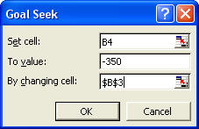
Insert Functions
Select Cell B4 and use the Function tool to calculate the PMT
The Rate (Cell B4) is divided by 12 to get a monthly payment
Your equation should look like this: =PMT(B2/12,B3,B1)
The payment is a negative number

Use Goal Seek
What would you meet the goal of a paying $350.00 for 60 months?

Save the spreadsheet and name it: Excel Advanced Practice 1

ECERCISE 18

Use Cell References
Open the sample Excel spreadsheet, Legs, Eggs, and Pigs in a Basket
When prompted, SAVE to your Documents folder

Initial | 100
Increment | 15
Date | Product | Net | Quantity | Revenue
February 17, 2003 | Eggs | $ 1.50 | 100 | $ 150.00
February 18, 2003 | Eggs | $ 1.50 | 115 | $ 172.50
February 19, 2003 | Eggs | $ 1.50 | 130 | $ 195.00
February 20, 2003 | Eggs | $ 1.50 | 145 | $ 217.50

Add Another Product
Copy the Eggs spreadsheet
Rename the copied spreadsheet: Fruit
Change the Product from Eggs to Fruit Baskets

Edit the Data
Change the Net: $2.25
Change the Initial: 50
Edit the Increment : 5

Update the Summary Sheet
Add the Fruit Basket data to the equations in the Summary Sheet in
Cell C3 would be: =Eggs!E6+Legs!E3+Pigs!E3+Fruit!E3

ECERCISE 19

Create a Sales spreadsheet
Open a new worksheet and rename it Bonus
Add the following labels across Row 1:
Add the names of the sales reps in Column A: Alex, Connie, Elizabeth, and Niki.
Add the following sales data in Column B.
Format Column D for currency and Column E for percent
Add the following data:

 | A | B | C | D | E | F
1 | Reps | Sales | Bonus  Percent | Goal | Percent | Bonus Check
2 | Alex | $ 3,500.00 |  | $2,500 | 5%
3 | Connie | $ 8,310.00 |  | $5,000 | 10%
4 | Elizabeth | $ 8,170.00 |  | $7,500 | 15%
5 | Niki | $13,560.00 |  | $10,000 | 20%
6 | Deeter | $ 3,500.00

Name the Range:
Select cell D1 through E5 and use the Name Box to name the range: Sales

Calculate the Bonus Percent with the Sales Lookup table
Select cell C2 and go to Formulas-> Insert Function
From the category list, choose Lookup and Reference, find VLookup
The first argument asks: "Where is the data?" The sales data for Alex is Cell B2.

The second argument asks: "Where is the look up table?” For the range, type the name "Sales" (or use the red, white and blue Find button to go to the spreadsheet to select the cells D1 through E5)

The third argument asks: “Where are the answers?” In our two column Sales table, the correct percents are located in Column 2.

Calculate the Bonus Check
Now all of the pieces are in place to figure out how much bonus the sales reps receive. Select Cell F2 and enter the following equation =B2*C2

