Kinetic theory of gases

BLOCK

16

# Introduction

This last block of module PHY 102 is dedicated to the kinetic theory of gases.

The kinetic theory of gases is the study of the composition and the physical properties of gases based on statistical methods of research. Thus, that theory is a part of classical statistical physics.

Key words

Fundamental equation of the kinetic theory

Pressure

Velocity

Root mean square velocity

Maxwell’s distribution

Most probable velocity

Arithmetical average velocity

Law of equipartition of energy

Altimeter

Boltzmann’s formula

Barometric formula

# What is in this block?

This block comprises 4 sections:

Section 16.1 Basic principles of kinetic theory of gases

Section 16.2 Fundamental equation of kinetic theory of ideal gases

Section 16.3 Maxwell’s law on the distribution of molecules in                                  an ideal gas according to the velocities and                                  energies of thermal motion

Section 16.4 Barometric formula and Boltzmann’s distribution

# Estimated study time

You will need between 5 and 6 hours to study this block. But do not worry if it takes less or more time, we do not all work at the same pace.

# Learning objectives:

After the study of this block, you should be able to:

* give basic principles of kinetic theory of gases
* give the physical meaning of thermodynamic temperature from the kinetic theory point of view
* give the fundamental equation of kinetic theory of pressure and average kinetic energy
* derive the law of equipartition of energy by degree of freedom from the Maxwell’s law of distribution of molecules in an ideal gas according velocities and energies of thermal motion.
* give barometric formula and starting from it find Boltzmann’s distribution
* apply kinetic theory of gases in doing exercises

# Section 16.1 Basic principles of the                           kinetic theory of gases

Kinetic theory of gases is based on the following general principles of classical statistical physics:

* for a system of particles, the following laws of conservation hold: the law of conservation of energy, the law of conservation of linear momentum, the law of conservation of electric charge (for a system of charged particles), the law of conservation of number of particles(for a closed system of particles, where chemical reactions and other transformations of particles are absent), …
* all the particles are "marked", i.e. identical particles (for example two molecules of the same gas) are distinguishable.
* all physical processes in the system occur in space and time in a continuous way. The description in space and time of any physical phenomenon in classical mechanics and statistical physics suppose the possibility of continuous changes in all physical quantities characterizing the state of the system.
* each particle of the system can have any coordinates (in the limits of the volume of the system) and any components of the velocity independently on the values of these parameters for other particles.

Statistical method is based on the use of the theory of probabilities and determined models of the structure of a considered system. For a system constituted by a large number of particles, there are some average values (mean values) of physical quantities characterizing all the system.

# Section 16.2 Fundamental equation of                            kinetic theory of ideal                           gases

An ideal gas can be considered as a system constituted by balls (molecules) in chaotic motion. The proper volume of molecules should be negligible and molecules do not interact at distance. Molecules are continuously in collision with other molecules of the gas and with the walls of the container exerting on them some pressure.

☞

**Thus, pressure is the macroscopic manifestation of thermal motion of the gas molecules**.

If the gas is not in an external field force, taking into consideration the chaotic motion of gas molecules, the pressure of a gas on all the walls is the same and numerically equal to the average force applied (exerted) on a unit surface area of the wall in a normal direction to that surface.

☞

**The fundamental problem of the kinetic theory of ideal gases is the calculation of the pressure of an ideal gas on the basis of molecular kinetic representations**.

Intermolecular collisions in the gas are more frequent than collisions of the molecules on the wall of the container, but Maxwell has shown that in the case of an ideal gas, intermolecular collisions do not influence the pressure exerted by molecules on the walls of the container. Furthermore, Maxwell has shown that the gas pressure on the walls does not depend on the nature of the material the walls are made of (as it will be seen from the equation of state).

Let us consider a monatomic ideal gas in a container (figure 16.1)

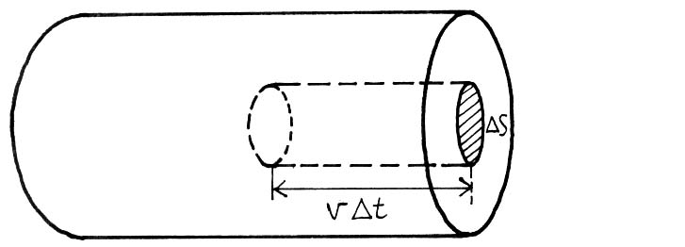

Figure 16.1. On the calculation of the pressure of an ideal gas

Let us choose some elementary surface on the walls of the container and calculate the pressure exerted by the gas on the surface , at each collision with that surface, a molecule moving perpendicularly to the surface  transfer to that surface a momentum

 (16.1)

where  is the mass of the molecule, *v* is the velocity of the molecule. During the time interval  the surface will be attained only by molecules which are enclosed in the volume of a cylinder whose base is and height is (see figure 16.1).

The number of these molecules is equal to:

 (16.2)

where *n* is the concentration of molecules.

However, we have to take into consideration that in reality molecules are moving toward the base of the cylinder under different angles (and not only perpendicularly) and with different velocities and the velocity of each molecule can change (in magnitude and direction) at any collision. To simplify calculations, let us replace the chaotic motion of molecules by the motion along three perpendicular axes in such a way that at any time of these molecules move along one of these axes, and the half of them (i.e.) move in one direction and the other half move in the opposite direction.

Therefore, the number of collisions of molecules moving in a given direction to the surface  is

 (16.3)

when molecules enter in collision with the surface, they transfer to that surface a net momentum

 (16.4)

Thus, the gas exerts on the walls a pressure

 (16.5)

Thus,

 (16.6)

If the volume of the gas is  and the gas contain *N* molecules with speeds, then we have to consider not the speed *v* but the root-mean-square speed *vq*

 (16.7)

(The root-mean-square speed is often denoted by  )

Therefore, we get:

 (16. 8)

Equation (16.8) is called **fundamental equation of kinetic theory of gases for pressure.**

**Remark:**

The exact calculation, which takes into consideration the motion of molecules in all possible directions, gives the same result.

Since , we get from (16. 8) :

 (16.9)

 (16.10)

On the other hand, we know that the total kinetic energy of the translational motion of all the molecules of a gas is given by:

 (16.11)

Comparing (16.10) with (16.11) we get:

 (16.12)

Let the total mass of the gas be *m*.

In that case  and

 (16.13)

For one mole of a gas, where is the molar mass, we get:

 (16.14)

where  is the molar volume. From the equation of state of an ideal gas (Clapeyron-Mendeleev equation)

 (16.15)

and therefore, from (16.14), we get:

 (16.16)

Hence,

 (16.17)

Since where  is the mass of one molecule and  is the Avogadro number, from (16.17), we get;

 (16.18)

where  is the Boltzmann’s constant.

The average kinetic energy of translational motion of a molecule of an ideal gas is:

 (16.19)

Thus, the average kinetic energy of translational motion of a molecule of an ideal gas is proportional to the thermodynamic temperature:

 (16.20)

From equation (16.20), it follows that when.

Thus, when temperature T reaches the value 0K, the translational motion of ideal gas molecules ceases, and therefore the pressure equals zero.

☞

Therefore, the thermodynamic temperature is the measure of the average kinetic energy of translational motion of ideal gas molecules and equation (16.20) gives the meaning of the temperature from the point of view of kinetic theory.

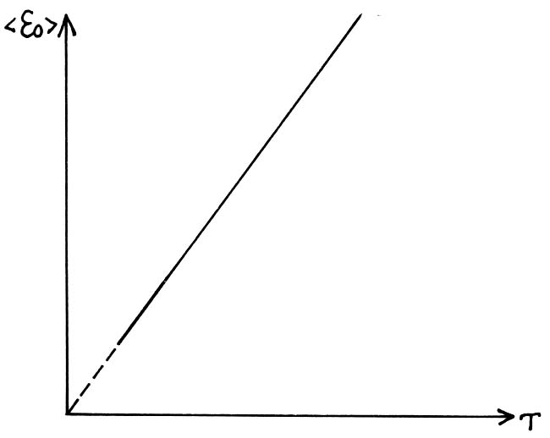

**Figure 16.2: Qualitative dependence **

**Remark:**

The linear dependence  does not hold for low temperatures close to 0K.

In that temperature range, laws of kinetic theory of gases and in general, the results of classical statistical physics are no longer applicable. This is the region of quantum statistics, which is beyond the scope of the present module.

### Activity16.1🖉

In this activity, take

 (Avogadro’s number)

 (universal gas constant)

 (Boltzmann’s constant)

1. The root-mean-square speed of a gas in normal conditions is 480m/s. How many molecules are contained in 1g of that gas?
2. Determine the pressure exerted by the gas on the walls of a container if the gas density is equal to 0.01 kg/m, and the root- mean-square speed of that gas is 480m/s.
3. Determine the average kinetic energy of the translational motion of molecules of a gas under a pressure of 0.1 Pa.

The concentration of molecules of gas is .

Feedback:

Do this activity and compare your answers with those provided at the end of this block.If you do not meet any difficulties while doing this activity, you can go to the next section. Otherwise review section 16.2. If needed, seek help from a colleague or your Tutor at the Regional Centre.

# Section 16.3 Maxwell’s law on the distribution of molecules in an ideal gas according to the velocities and energies of thermal motion

According to the kinetic theory, the root-mean-square speed of a molecule of mass  in a gas in thermodynamic equilibrium state (at *T=const)* remains constant and is:

 (16.21)

or

 (16.22)

This can be explained by the fact that in a gas in a thermodynamic equilibrium state, some stationary distribution of molecules according to the speeds and governed by a well defined statistical law takes place. This law was theoretically established by Maxwell.

Maxwell assumed that the gas is constituted by a large number N of identical molecules in a chaotic thermal motion at the same temperature. He assumed also that there are no force fields acting on the gas.

The law of Maxwell’s distribution is described by some function called **function of the distribution of molecules according to speeds.**

If we divide the interval of molecule speeds into small intervals equal to, then to each small interval of speeds will correspond some number of molecules  having a speed belonging to that interval.

The function determines the relative number of molecules , whose speeds are in interval , i.e.

 (16.23)

or

 (16.24)

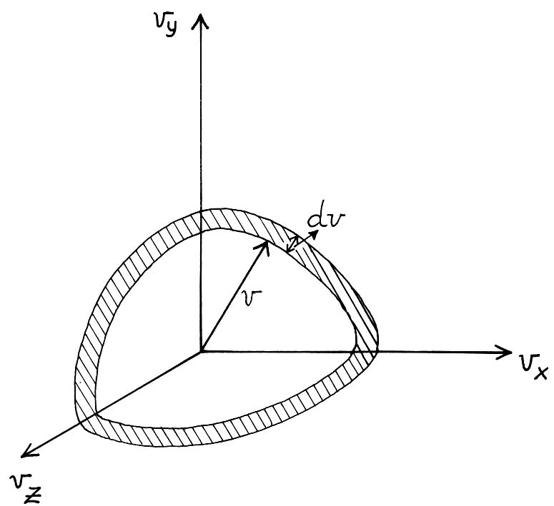

**Figure 16.3. Interval of speeds **

Using the models of theory of probabilities, Maxwell found that:

 (16.25)

The concrete form of the distribution function f(v) depends on the type of gas (more precisely on the mass  of molecules) and on a state parameter (more precisely, the temperature T).

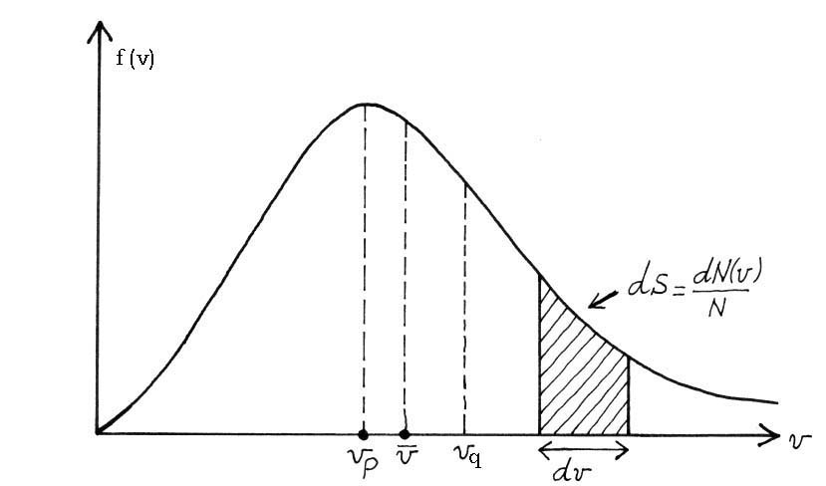

**Figure 16.4. Dependence f (v)**

The function f(v) fulfils the normalization condition:

 (16.26)

The speed corresponding to the maximum of the distribution function of molecules is called **the most probable speed .**

This speed is obtained by solving the equation:

 (16.27)

which gives

 (16.28)

The values *v = 0* and in equation (16.28) correspond to the minimum values of the distribution function f(v), whereas

 (16.29)

is the most probable speed (i.e. the speed corresponding to the maximum value of).

When temperature increases, the maximum function of molecule distribution according to speeds is displaced on the right (which means that the most probable speed also increases) but the surface enclosed by the curve and the speed axis remains constant (equal to 1).

This means that the maximum value of *f* *(v)* becomes more and more small when temperature increases (figure 16.5)

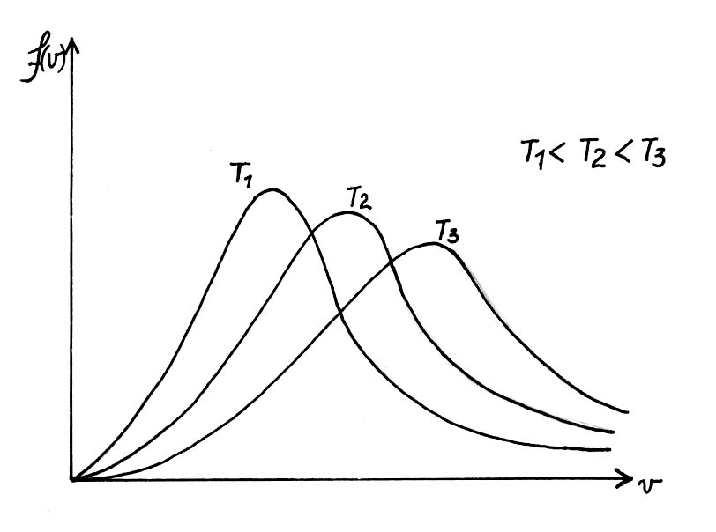

**Figure 16.5 Dependence *f (v)* for different temperatures**

**The arithmetic average speed ** is defined as follows:

 (16.30)

After integration, we get:

 (16.31)

As we have seen above, the root-mean-square speed is defined as:

 (16.32)

The comparison of formulae (16.29), (16.31) and (10.32) shows that

 (16.33)

(the root-mean-square speed is greater than the arithmetic average speed, which is itself greater than the most probable speed).

Using formulae (16.23)-(16.25), we have 

From the distribution of molecules according to speeds (16.34), we can get the distribution of molecules according to kinetic energy .

Let us make a change of variables from *v* to .

In that case, we have

 (16.35)

 (16.36)

and

 (16.37)

where  is the number of molecules having kinetic energy in interval .

Therefore, the distribution function of molecules according to energy of thermal motion is:

 (16.38)

The average kinetic energy  of one molecule of a monatomic ideal gas is

  (16.39)

Thus,

 (16.40)

As it was expected, we have found the same result as the result (16.20), obtained above as the average energy of translational motion of the molecule.

Since the kinetic energy of a molecule is equal to three times *kT* and the molecule has three equivalent degrees of freedom, we can conclude that to each degree of freedom corresponds an average energy equal to. This result established for a monatomic ideal gas holds also for a polyatomic ideal gas and constitutes **the law of equipartion of kinetic energy according to degrees of freedom**.

Let us recall that the number of degrees of freedom is equal to the minimum number of independent parameters to be given in order to determine completely the state of the system.

Thus, the average kinetic energy of a molecule having *i* degrees of freedom is equal to:

 (16.41)

The internal energy of an ideal gas is constituted by the kinetic energy of its molecules.

For one mole, we have:

 (16.42)

Thus, the internal energy of an ideal gas depends linearly on thermodynamic temperature of that gas *(T)* and on the number of the degrees of freedom of its molecules *(i).*

**Remark:**

This conclusion does not hold for a real gas. In real gases, the internal energy comprises also the potential energy of interactions between molecules which depends on average distance between molecules, i.e. on the specific volume of the gas, and on the types of intermolecular forces. For this reason, the internal energy of a real gas cannot be found only on the basis of the law of equipartition of energy by degrees of freedom.

### Activity16.2.🖉

1. Determine the most probable speed of molecules of a gas whose density is 0.35 kg/munder a pressure of 40 kPa.
2. At which temperature the root-mean-square speed of molecules of oxygen is more than the most probable speed by 100 m/s ?
3. Using the law of distribution of molecules of an ideal gas according to speeds, find the expression for the most probable speed.
4. Using the law of distribution of molecules of an ideal gas according to speeds , find the expression for the root-mean-square speed.
5. At while doing this activity, then you can pass to the next section. Otherwise review the content of section 16.3.

Feedback:

Do the exercises of this activity and compare your answers with those provided at the end of this block. If you do not have any difficulties while doing this activity, then you can go to the next section. Otherwise, review the content of section 16.3

# Section 16.4 Barometric formula and                          Boltzmann’s distribution

The fundamental equation of kinetic theory of gases was obtained by assuming that external forces do not act on molecules of a gas and therefore, these molecules are uniformly distributed in all the volume of the gas.

However, molecules of any gas are in the field of gravity. The force of gravity from one side and the thermal motion of gas molecules from the other side lead to some stationary state of the gas in which the pressure of the gas decreases with the height.

If there were no thermal motion, all the molecules of the atmospheric air should fall on the earth because of the gravity; and if the force of the gravity were absent, all the atmospheric air will scatter in the all universe.

Let us find the law of the dependence of pressure on the height by assuming that:

1. the field of gravity is uniform
2. the temperature is constant
3. the molecular mass is the same for all molecules

Let us analyse a column of a gas located at a height *h* and having a width *dh* and the area of the surface equal to unit (figure 16.6).

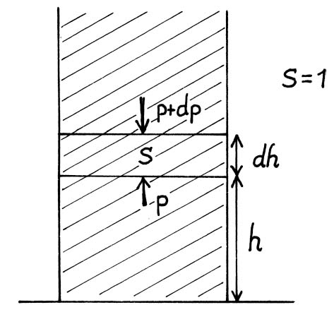

**Figure 16.6. Column of a gas of a width *dh* at a height *h*.**

The difference between pressures *p* (on the lower base) and *p+dp*

(on the upper base) i.e. pressures at heights *h* and is equal to the hydrostatic pressure  of the gas column:

 (16.43)

From Clapeyron-Mendeleev’s equation:

 (16.44)

we get:

 (16.45)

From the above equation, we obtain:

 (16.46)

or

 (16.47)

Integrating (16.47), we get:



and



which leads to:

 (16.48)

or

 (16.49)

Thus, we have obtained a relation known as the **barometric formula:**

 (16.50)

where  is the gas pressure when h=0.

The barometric formula allows to find atmospheric pressure in function of height, or by measuring the pressure, to find the height:

 (16.51)

The barometer especially designed to measure the height above the sea level is called **altimeter.** It is widely used in aviation and alpinism.

The barometric formula allows to get the ratio between the concentrations of gas at different heights. Using the state equation, we get:

# (16.52)

# where

# (16.53)

is the concentration of the gas molecules at a pressure  (at a height *h=0).*

At a constant temperature *T*, we have

 (16.54)

where is the concentration of molecules of a gas at the pressure . Therefore, by using concentrations of the gas at heights *h=0* and *h=h* respectively, the barometric formula can be put into the form:

 (16.55)

Making the substitution

 (16.56)

where  is the mass of a molecule of gas, we get

 (16.57)

From (16.57) we see that *n0*tends to *n00* when temperature tends to infinity. Thus, the temperature increase leads to the fact that concentrations of gas in all the volume occupied by that gas are equal. When temperature tends to zero, the concentration *n0*tends also to zero. This means that under action of the force of gravity molecules will go down on the bottom of the container.

☞

**Thus, our atmosphere exists thanks to thermal motion of particles and to gravity.**

From mechanics, we know that

*m g h = U* (16.58)

represents the potential energy of molecules in a uniform field of gravity near the earth’s surface (on conditions that  ).

Thus,

 (16.59)

Formula (16.59) is known as **Boltzmann’s distribution in external potential field**.

**Remark:**

Boltzmann’s distribution holds for any potential field regardless of its physical nature. This law is widely used in physics. For example, using Boltzmann’s distribution, we can experimentally determine one of the universal constants in physics: the Avogadro’s number.

Indeed,

 (16.60)

but



which leads to

 (16.61)

from where we get:

 (16.62)

Thus, by measuring and , we can get using (16.62).

### Activity 16.3🖉

1. At which height does the air pressure constitutes 60% of air pressure at the sea level? Assume that temperature of air is the same and is equal to 10C.
2. Determine the ratio of air pressures at 1 km above the earth’s surface and in a well 1 km deep. The air at the earth’s surface is in normal conditions and its temperature does not depend on the height.

Feedback:

If you do not meet any difficulties while doing this activity, congratulations! You have completed the study of module PHY 102. Otherwise, review the content of section 16.4 and come back to this activity.

# Block summary:

* The fundamental equation of kinetic theory of gases:



or



or



where is the root-mean- square speed (often denoted by ) of molecules, *E* is the net kinetic energy of translational motion of all the molecules of the gas, *n* is the concentration of molecules,  is the mass of the gas, and *N* is the number of molecules of the gas in the volume *V*.

* The most probable speed of molecules is given by:



The root-mean-square speed is given by:



The average arithmetic speed of molecules of an ideal gas is:



* Maxwell’s law of distribution of molecules of an ideal gas according to speeds is:



* Maxwell’s law of distribution of ideal gas molecules according to energies of thermal motion is given by:



* The barometric formula is given by:



where *p* and *p0* are the gas pressures at heights h and h0, respectively.

* Boltzmann’s distribution in external potential field is given by:



where  and are respectively the concentrations of molecules at height *h* and *ho*,  is the potential energy of a molecule in the field of gravity.

#### References:

* F.W.Sears and G.L.Salinger (1975). *Thermodynamics, Kinetic Theory and Statistical Thermodynamics, 3rd Edition*. Addison-Wesley Publishing Company
* B. Yavorski and A. Detlaf (1986). *Aide-mémoire de physique*. Moscou ,Editions Mir.
* Kashinje, S.P. and Baziruwiha J.D. (2003). *Physique, module 6: Thermodynamique*. Kigali Institute of Education
* H.D.Young and R.A.Freedman (2000). *University Physics with Modern Physics*. Addison-Wesley Publishing Company.

## Answers to activity of block 16.

#### Activity 16.1

1. **Given**:









**Find**: *N*(the number of molecules in 1g of gas)

**Solution**:









1. **Given**:





**Find**: *p*

**Solution**:



(Clapeyron- Mendeleev equation)







**Given**: 



**Find**: 

**Solution**:



but 







#### Activity 16.2.

1. **Given**:





**Find**: (the most probable speed).

**Solution**:









**Given**:





**Find**: (temperature)

**Solution**:











**Given**:



**Find**: 

**Solution:**





=0



**Given**: 

**Find** : vq

**Solution**:





Using the formula 

with 

we get:







#### Activity 16.3

1. **Given:** 





**Find**: *h*

**Solution:**













1. **Given**:







**Find**: 

**Solution**:











# Module summary

In this module, you learnt properties of matter and thermodynamics. In Block 1, you studied the molecular force and the molecular potential energy. Some properties of different states of a matter, viz., thermal expansion, transformation of one state to other, density of different states, etc., were explained on the basis of molecular interactions.

In first module of physics (PHY 101: Mechanics) you studied about rigid bodies. In this module you learnt that the concept of rigid body is idealisation. Every body alters its size or shape under the action of applied force.

In Blocks 2, 3 and 4, you learnt about elastic properties of matter.

In Block 2, the basic principles of elasticity for homogeneous and isotropic materials– Hooke’s law for tangential and lateral strains (Young’s modulus and Poisson’s ratio), and the principle of superposition for elasticity– were discussed. In Block 3, you studied some other moduli of elasticity, viz., the bulk modulus and the modulus of rigidity, and relations between different moduli of elasticity. In Block 4, experimental methods for determination of some moduli of elasticity were discussed in detail.

Fluids deform continuously under the action of shearing forces, however small they may be. Conversely, it can be said that if fluids are at rest, there can be no shear forces acting. Therefore, the basic law of fluid statics is that all forces in the fluids at rest are always normal to the planes upon which they act. In Block 5, you studied Pascal’s principle and Archimedes’ principle and their applications. In Block 6, you studied surface tension of liquids and its applications. In Block 7, you learnt some basic principles of fluid dynamics, namely, continuity equation, equation of motion and Bernoulli’s equation. The concepts of Newton’s second law of motion, law of conservation of energy, which you studied in module PHY101, were very useful while discussing fluid dynamics.

In Block 8, you studied 3 transport phenomena, namely, viscosity of fluids, thermal conduction and molecular diffusion. You learnt some similarity in equations describing these phenomena. The concepts related to gradient, divergence and curl, which you learnt in module PHY101, were widely used in Blocks 7 and 8.

From Block 9 to Block 16 you learnt thermodynamics, what it represents and its applications.

Modern thermodynamics is a science studying the relationship between different forms of energy and the influence of that relationship on properties of physical bodies.

Block 9 dealt with mains concepts and representations of thermodynamics.

In Block 10 you learnt the first law of thermodynamics which is mainly the law of conservation of energy. First law of thermodynamics deals mainly with heat, work and internal energy. Amount of heat and work are not properties of a given system and depend on the process in which the system is involved. They are functions of a process. In the contrary, internal energy is a property of a system i.e. internal energy is a function of state.

In Block 11 you learnt the second law of thermodynamics. You learnt that there are processes that cannot occur naturally (spontaneously) even if they are non contradictory to the first law of thermodynamics. A system that violates the second law of thermodynamics is called a perpetuum mobile of second kind. Often the second law of thermodynamics is given by Clausius statement and Kelvin-Planck statement. You have seen that these two statements are equivalent. By using the concept of entropy, the second law of thermodynamics can be stated quantitatively. You have seen that entropy is the measure of disorder and can never decrease for an isolated system. It can either increase or remain constant.

Block 12 was dedicated to thermodynamic potentials and their applications. In this block, you learnt that knowing some functions of half of parameters characterizing the state of a system, you can find the other half of parameters of state of the system and other thermodynamic properties of that system by taking the derivatives of these functions. These functions are called characteristic functions or thermodynamic potentials.

In Block 13 the concept of phase was defined and conditions of equilibrium between phases were stated. You have studied the Gibbs phase rule and the curves of equilibrium, and defined the concepts of triple point and critical point on a p-T diagram. Finally in that block you have studied phase transitions and their classifications.

Block 14 concerned with the methods for obtaining low temperatures and gas liquefaction. A great attention was paid on Joule-Thomson effect and on the method of reversible adiabatic expansion.

The third law of thermodynamics or Nernst’s theorem was analysed in Block 15. This law finds its applications usually for processes occurring at low temperatures. According to that law one cannot attain absolute zero of temperature, one can only approach it asymptotically.

Finally, Block 16 is concerned with the kinetic theory of ideal gases. Here, you have seen basic principles of kinetic theory of ideal gases, fundamental equation of kinetic theory of ideal gases, Maxwell’s distribution and Boltzmann’s distribution. Thermodynamics is a phenomenological theory lying on the descriptive method. It is a very powerful method of investigation in which only global macroscopic properties of matter are involved. Thermodynamic method is limited in that sense that it does not take interest in the microscopic constitution of matter and in the mechanism of processes. It only establishes relations between macroscopic properties of matter. This gap is filled by statistical physics. In Block 16 we have somehow introduced statistical method when we have studied the kinetic theory of ideal gases. A detailed study of statistical physics is out of the scope of this module.

The detailed summary of each block is given at the end of the block.

# Bibliography

* Alonso, M. and E.J. Finn, (1980). *Fundamental University Physics.Vol. I*, Addison-Wesley Publishing Company, Reading, Massachusetts
* Bazarov, I. (1989). *Thermodynamique*. Edition Mir, Moscou
* Baziruwiha, J. D. (2002). *Physics Module 3: Mathematical Physics I: Part A*, Kigali Institute of Education.
* Baziruwiha, J. D. and Ntivuguruzwa C. (2009). *Physics Module PHY101: Mechanics*, Kigali Institute of Education.
* Boccara, N. (1968). *Les principes de la thermodynamique classique*. Presses universitaires de France
* Brij Lal and N. Subrahmanyam, (1999). *Properties of Matter*, Eurasia Publishing House
* Brij Lal and N. Subrahmanyam (2001). *Heat and Thermodynamics*. S.Chand Co. Ltd New Delhi
* Cutnell, J.D.; K.W. Johnson & H.M.Smith (1998). *Student`s Pocket Companion Cutnell and Jonson. Physics, Fourth Edition.*
* Dufresne, RJ, W.J. Gerace and William J. Leonard, *Solving Physics Problems with Multiple Representations,* The Physics Teacher **35**, 270-275, May (1997).
* Feynman, R.P. , R.B. Leighton and M. Sands, (1977). *The Feynman Lectures on Physics Vol. I*, Addison–Wesley Publishing Company, Reading, Massachusetts
* Gibbs, K. (1996). *Advanced Physics*, Cambridge University Press
* Irodov, I.E. (1981) *Problems in General Physics*. Mir Publishers, Moscow
* Kariotogloy, P. , P. Koumares and D. Psillos, *A Constructivist Approach for Teaching Fluid Phenomena*, Physics Education **28**, 164-169 (1993), and references therein.
* Kashinje, S.P. and Baziruwiha J.D. (2003). *Physique, module 6: Thermodynamique*. Kigali Institute of Education.
* Kubo R., Ichimura H., Usui T.and Hashitsume N. (1968). *Thermodynamics*. North-Holland Publing Company-Amsterdam, John Willy and Sons, I. New York.
* Landau, L. and Lifchitz, E. (1980). *Course of Theoretical Physics. Volume 5.* *Statistical Physics, part I*. Pergamon Press , third edition.
* Larkin, Jill, J. McDermott, D.P. Simon and H.A. Simon, *Expert and novice performance in solving problems*, Science **208**, 1335-1342, June (1980).
* Léontovith, M. (1986). *Introduction à la thermodynamique. Physique statistique*. Moscou : Editions Mir
* Mathur, D.S. (2000). *Mechanics*, S. Chand & Company
* Ntivuguruzwa, C. (2002). *Physics Module 4: Mathematical Physics I: Part B*, Kigali Institute of Education
* Prescott, John (1961). *Applied Elasticity*. Dover Publications, Inc.
* Reif, F. *Millikan Lecture 1994: Understanding and teaching important scientific thought processes*, American Journal of Physics **63** (1), 17-32, January (1995), and references therein.
* Sears, F.W. and M.W. Zemansky, H.D. Young and R.A. Freedman *University Physics*, Addison-Wesley Publishing Company (2000).
* Sears, F.W. and G.L.Salinger (1986). *Thermodynamic, Kinetic Theory and Statistical Thermodynamics*. Addison-Wesley Publishing Company, 3rd Edition
* Sprackling, R.T. (1970). *The mechanical properties of matter*, The English Universities Press Ltd., London
* Tipler, P. A. (1991). *Physics for Scientists and Engineers*, Worth Publishers
* Wilson, J.D. (1993) *Physics*, Saunders College Publishing, Harcourt Jovanovich College Publishing.
* Yadav L.L. (2003). *Physique, module 5 : Les propriétés de la matière*. Kigali Institute of Education
* Yavorski, M. and Detlaf, A.(1986). *Aide mémoire de physique*. Moscou. Editions Mir.
* Yavorsky, B.M. and A.A. Pinsky, *Fundamentals of Physics*, Mir Publishers, Moscow (1987).

# Glossary

**Adhesive force**: molecular force between different/dissimilar molecules, e.g. between mercury and glass molecules.

**Adiabatic gas**: during the expansion or compression of a gas, there is no exchange of heat.

**Adiabatic process**: a process which occurs without a heat exchange with the surroundings

**Adiabatic walls:** perfectly insulating walls that do not allow heat to flow between the system and its surroundings.

**Amount of heat:** amount of energy transferred from one system to another during thermal interaction.

**Angle of contact**: the angle between the solid surface and tangent plane to the liquid surface, measured through the liquid.

**Archimedes’ principle**: the buoyant force on a body completely or partially immersed in a fluid is equal to the weight of the fluid displaced by the body.

**Barometer**: an instrument used to measure atmospheric pressure.

**Beam**: a rod or bar of uniform cross-section, whose length is large compared to its thickness.

**Bernoulli’s principle** **(equation)**: a statement of conservation of energy for fluids: for an incompressible, irrotational steady flow of a fluid with no viscosity, the sum of kinetic energy, gravitational potential energy and pressure energy per unit volume remains constant.

**Brittle**: materials which break as soon as stress is increased beyond elastic limit

**Buoyant force**: The upward thrust (force) on body when it is submerged in a fluid.

**Cantilever**: If the beam is fixed horizontally at one end and loaded at the other end, it is called a cantilever.

**Capillarity**: The depression or elevation of the liquid in a narrow tube due to adhesion or cohesion and surface tension.

**Carnot’s cycle:** a cycle which comprises four processes: two isothermal processes and two adiabatic processes

**Carnot’s theorem:** the efficiency of a reversible Carnot cycle does not depend on the nature of the working body and it is only a function of thermodynamic temperatures of the hot reservoir () and the cold reservoir : 

The thermal efficiency of a reversible cycle cannot be greater than the efficiency of a Carnot cycle: .

**Chemical equilibrium**: equilibrium characterized by the equality of chemical potentials in all the phases of a system.

**Closed system:** system which has no material exchange with the environment.

**Coefficient of performance (COP) or efficiency () of a refrigerator or a heat pump:** the quantity equal to the ratio of the transferred heat by the cold reservoir, in a reverse Carnot cycle, to the work used in that cycle: .

**Cohesive force**: molecular force between similar molecules.

**Component:** a part of a system whose composition does not depend on that of other parts.

**Critical point**: a point on a p-T diagram where the curve of equilibrium between liquid and gaseous phases ends and from which these two phases can not be distinguished physically.

**Cycle (closed process)**: a series of thermodynamic transformations after which the system returns to its initial state.

If after a process the system returns to its initial state, then that process is called a cyclic process (or cycles).

**Density**: A measure of the compactness of the particles in a material, which is defined as mass per unit of volume.

**Diathermal walls:** walls of the system that allow heat to flow through.

**Diffusion**: When there is concentration gradient of any molecular species, due to the random molecular motion, after a sufficiently long time, all the molecules are uniformly distributed through the whole volume. This phenomenon is known as diffusion.

**Direct cycle:** a closed transformation whereby a system performs a positive work. In this case the working body undergoes a close curve clockwise.

**Ductile**: any material which does not break just beyond the elastic limit. These materials have quite a good plastic range.

**Efficiency of a heat engine:** a quantity equal to the ratio of the work W done by the working body in direct reversible cycle to the amount of heat received by the working body from the hot reservoir: .

**Elasticity**: by virtue of this property, a solid recovers its original shape after removing the distorting force.

**Entropy**: a function of state *S* such that reversible.

**Equation of state**: the equation of state of a system is an equation which relates together its different state parameters in thermodynamic equilibrium.

**Equipartition theorem**: to each degree of freedom corresponds an average kinetic energy equal to .

**Extensive (or additive) parameters**: parameter which are proportional to the mass or to the number of particles in the system.

**External parameters:** quantities determined by external bodies which are not part of the considered macroscopic system.

**First law of thermodynamics:** the change in internal energy of a macroscopic system during a transition from initial state "1" to the final state "2" is equal to the sum of the work done on the system W by all the external macroscopic forces and the heat amount Q imparted to the system:



or



where W is the work done by the system on external bodies.

**Fluid**: any substance that can flow is called fluid. Liquids and gases are fluids.

**Function of a process**: function having different values for each different method used to make the system change from one state to another.

**Function of state:** function which depends only on the state of a system, and not on the method by which the system arrives at a given state.

**Generalized thermodynamic potentials**: thermodynamic potentials for systems whose state is determined by many parameters

**Gibbs phase rule:** in a given system, the number of phases which can coexist in equilibrium can exceed the number of components not more than by two.

**Heat capacity**: the heat amount needed to impart to a body in order to increase its temperature by one kelvin. It is a function of process.

**Heat engine**: an engine which takes heat from a hot reservoir, does a work and gives heat to a cold reservoir

**Heterogeneous system:** a system composed of many physically homogeneous parts (bodies) and inside which physical properties change in a discontinuous manner

**Homogeneous system:** system in which properties change in a continuous way when one passes from one place to another.

**Incompressible fluid**: a fluid whose density remains constant.

**Intensive parameters:** parameters which do not depend on the mass and the number of particles of the system, and characterize the general state of the thermal motion of a body.

**Internal energy:** the energy within the system. It includes the energy of all possible kinds of motion and interaction of all the particles (molecules, atoms, nuclei, etc) constituting the system. For example, the internal energy of a system in a gaseous state is composed of the kinetic energy of the chaotic thermal motion of molecules, and the kinetic energy of oscillatory motion of atoms in molecules, the potential energy due to the forces of interaction between molecules, the energy of electronic shells of atoms and ions, the energy of motion and interaction of nucleons in atomic nuclei. Internal energy is a function of state of a system.

**Internal parameters:** quantities determined by the motion and the distribution in space of the particles constituting the system.

**Irreversible process:** a process that can go only into one direction.

**Isochoric process:** process that occurs at constant volume.

**Isothermal gas**: During expansion or compression of the gas, the temperature of the gas remains constant.

**Isothermal process:** process that takes place at constant temperature.

**Macroscopic parameters:** all macroscopic indices characterizing a given system and its relation with the environment.

**Macroscopic system**: any body composed of a large number of particles.

**Mechanical equilibrium**: equilibrium characterized by the equality of pressures in all the phases of a system.

**Mole**: Amount of a substance that contains the same number of particles (molecules or atoms) as the number of atoms in 12 grams of carbon-12 (an isotope of carbon).

**Molecular force**: An attraction or a repulsion force between molecules.

**Number of thermodynamic degrees of freedom**: number of independent parameters determining completely the state of a system in thermodynamic equilibrium.

**Open system:** system which can interchange the material with its surroundings. Its boundaries are permeable.

**Pascal’s principle**: The pressure applied to an enclosed fluid is transmitted undiminished to every other part of the fluid and to the wall of its container.

**Phase transition of first order**: phase transition which is accompanied by a jump (abrupt change) in internal energy and density. In such a transition, there is absorption or a release of heat.

**Phase transition of second order**: phase transition which is not accompanied by jumps in internal energy and density. There is neither heat absorption nor heat release.

**Phase transition**: transformation of a substance from one phase to another due to external actions.

**Phase:** a homogeneous part of a heterogeneous system separated from other parts by a surface on which any properties change discontinuously.

**Plasticity**: The property of a solid characterised by permanent deformation when a distorting force or stress is removed. Such solids are known as plastic bodies.

**Polytropic process**: a process whose the equation in variables p and V is of the form: *const*, with *n* being any number: positive, negative or zero. In a polytropic process, the heat capacity remains constant.

**Refrigerator**: a system which absorbs heat from a cold reservoir and releases heat to a hot reservoir

**Reverse cycle:** a cycle in which the working body transfers heat from a colder body to a hotter body on the expense of positive work done by external forces.

**Reversible process:** a process that once having taken place can be reversed and in so doing leaves no change in either system or surroundings.

**Second law of thermodynamics**:

* **Clausius statement:** It is impossible for heat to transfer spontaneously from a colder body to a hotter body without causing other changes.
* **Kelvin-Planck statement:** It is impossible to convert all the heat taken from a body of uniform temperature into work without causing other changes.

**Other statements:**

* A perpetuum mobile of the second kind is impossible
* The entropy of an isolated thermodynamic system can never decrease whatever processes in which the system is involved: .

**State of a thermodynamic system:** the form of existence of thermodynamic system defined by the set of its independent macroscopic parameters.

**State of thermodynamic equilibrium:** state in which the system is characterized not only by the invariance of all its parameters in time, but also by the absence of any stationary flux due to the action of any external sources.

**Statistical weight of a macrostate**: the number of different microscopic states corresponding to a given macroscopic state.

**Surface tension**: Force per unit length acting in the surface perpendicular to one side of a line in the surface.

**System:** in thermodynamics, the collection of objects upon which attention is being focused.

**Temperature of inversion**: temperature at which Joule-Thomson’s effect changes the sign: at temperatures below the temperature of inversion, the effect is positive; at temperature above temperature of inversion, the effect is negative.

**Temperature:** parameter determining the thermal equilibrium of diathermally isolated systems.

**Thermal conduction**: A mechanism of heat transfer in which heat is transferred between two systems through a connecting medium which does not move.

**Thermal equilibrium**: equilibrium characterized by the equality of temperatures in all the phases of the system.

**Thermal expansion**: When thermal energy of a body increases, it expands. This process is known as thermal expansion.

**Thermodynamic potentials or characteristic functions**: functions of half of variables of the state of a system and whose differentiation allows to find the other half of variables of state and other thermodynamic properties of the system.

**Thermodynamics**: a science studying the relationship between different forms of energy and the influence of that relationship on properties of physical bodies. Its main feature is the consideration of natural processes from the point of view of the transformation of energy in processes.

**Thermometer:** instrument used in the measurement of temperature.

**Thermometric bodies:** bodies having properties depending on temperature and used to construct a thermometer.

**Third law of thermodynamics**: as the temperature approaches absolute zero, the entropy of any system in equilibrium involved in isothermal processes ceases to depend on thermodynamic parameters of state and takes, at the limit T*= 0 K*, a constant value, the same for all systems, which can be assumed to be zero.

**Triple point**: point on a p-T diagram at which three phases coexist in equilibrium.

**Triple point of water**: a state where water (liquid), ice (solid) and water vapour coexist in equilibrium.

**Viscosity**: Internal friction in a fluid by virtue of it the fluid opposes the relative motion between its two parts.

**Work:** a change in internal energy of a macroscopic system done by the action of forces between bodies.

**Working body:** a body undergoing a cycle and exchanging energy with other bodies.

**Zeroth law of thermodynamics**: Two systems individually in thermal equilibrium with a third system are in thermal equilibrium with each other.