* 1. **Introduction**

Mainly transfer of new technology is done by extension agents but opinion leaders also play a big role in making them happens in the village through spreading the agricultural information to the followers and the farmers by the purpose of bringing the desirable change in the community (K. Ramakrishna,Ramakrishna, 2005). By referring to Linderman, a leader is someone who can convince a group of people through his relations, judgments and feelings as the bases of belief and actions.Opinion leaders are those individuals who have a greater-than-average share of influence

Opinion leaders are those individuals who can share influence within the community because they can change the attitude of others in an informal manner. They usually suit the principles of social system. They make use of unbiased and technically accurate source of information, they are better equipped than their followers in terms of knowledge, insight, and judgment in order to help them to adopt the innovation. Opinion leader are perceived as experts and trustworthy precisely because of their relative objectivity regarding innovations (Hameed, 2017).

* 1. **Objectives of the assignment**
* This will help us to know the way opinion leader can convince Non-adopters to become adopters for that innovation
* This will help us to understand well the role of opinion leader in the community

**2.0. Literature Review of the Topic**

**Characteristics of opinion leaders**

* Opinion leaders have greater exposure to mass media that are relevant to their area of interest:
* Exposure to relevant mass media provides them with information useful in
* enhancing their leadership potential

Exposure to relevant mass media provides them with information useful in enhancing their leadership potential.

As an example, opinion leaders for women`s fashion could be expected to have a higher exposure to such magazines as vogue and Glamour.

* Opinion leaders have a greater interest and knowledge of the area of the influence than do non leaders. This is closely related to their greater exposure to media
* Opinion leaders are more sociable and more companionable
* Opinion leaders are more innovativeness than do non-leaders: This does not mean, however, that they are innovators (the first people to purchase a new item
* This does not mean, however, that they are
* innovators (the first people to purchase a new item

this does not mean that they are innovators (first to purchase new item).

* Opinion leader are more familiar with and loyal to the group standards and values than non- leader. This refers to the facts that opinion leaders are vested with the leadership authority by group members, and in order to maintain this position, the individual has to reflect underlying the norms and values for that area of consumption leadership (Hameed,2017).

**The importance of working agent with opinion leaders**

There are four main aspects of working with local leaders which the agent should keep in mind:

1. Inform opinion leaders of extension activities and proposals for new programmes and keep them supplied with extension literature
2. Visit them as often as is necessary-enough to ensure that they are not isolated or let on their own. Try to make visit library so that the reader can build them into his own work routine (FAO,2017)
3. Train the opinion leader in the aspects of extension activities with which they may be unfamiliar, formal training session can be set up at which the leaders will learn about the new practice, how to run a demonstration or how to hold the farmers` meeting.
4. Encourage the opinion leader to take the initiative and to begin to act with some independence. The more they can become recognized and effective, the better chance the extension agent will have of making an impact in the area.

An extension agent who has the use of the service of a group of good, efficient opinion leader has a tremendous addition resource at his disposal and while be in a far better position to get extension work going in that area than if he had to work alone and unsupported

***Diffusion theory an approach used in opinion leadership***

Diffusion is the process by which innovation is communicated through a certain channel over a period of time among the member of social system. Whereas an *innovation* is an idea, practice, or object that is perceived to be new by an individual or other unit of adoption. *Communication* is a process in which participant create and share information with one another to reach a mutual understanding (Roger, 1995)

Opinion leaders exert influence on audience behavior via their personal contact, but the additional intermediaries called *change agent* and *gatekeepers* are also included in the process of diffusion. Five adopter categories are:

1. Innovators (2.5%)
2. Early adopters (13.5%)
3. Early majority (34%)
4. Late majority (34%)
5. Laggards (16%)

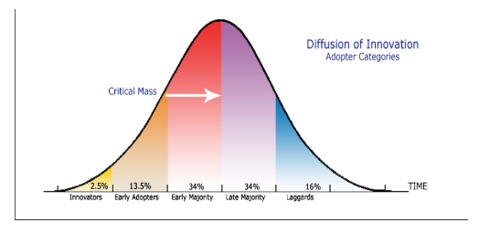

Figure: adopter categorization on the basis of innovativeness

within their community because they modify the opinions of others in an informal manner.

Opinion leaders usually conform closely to the norms of their social system

within their community because they modify the opinions of others in an informal manner.

Opinion leaders usually conform closely to the norms of their social system