

**COLLEGE OF AGRICULTURE, ANIMAL SCIENCES AND VETERINARY MEDICINE (CAVM)**

**SCHOOL OF AGRICULTURE AND FOOD SCIENCES**

Department**: Crop Sciences**

Option: **HORTICULTURE**

Module Name: **AGRICULTURE EXTENSION**

COMPONENT: **Technology Transfer Skills and Strategies**

**ASSIGNMENT QUESTION:** TWIGIRE MUHINZI is the knowledge Centre for farmers. Critically analyze the role of it in meeting the mandated objectives based on your understanding and interactions with the farmers, scientistsand extension functionaries in Rwanda.

**GROUP.2 MEMBERS:**

|  |  |  |
| --- | --- | --- |
| **NO** | **Names** | **STUDENT NUMBER** |
| 01 | HAKORIMANA Jean de Dieu | 217095488 |
| 02 | UMUHOZA Marie Aimee | 217073980 |
| 03 | MUKABERA Felicite | 217194192 |
| 04 | TUYIZERE Epiphanie | 217051235 |
| 05 | NZABITONDERA Alphonse | 217184138 |
| 06 | ISHIMIRWE Alda | 217203361 |
| 07 | HABINEZA Colleb | 217036074 |

**Lecturer: Dr. HABIMANA Sylvestre**

Done on 30th.octomber. 2020

**I. INTRODUCTION**

Government of Rwanda made a homegrown solution for farmer to increase their yield and foster solidarity. They gave it the name of TWIGIRE MUHINZI (MINAGRI, 2016).

TWIGIRE MUHINZI is a government program where farmer raised their capacity of increasing quality and quantity of production by getting fertilizers and good quality seed under government support (Nkunganire). They play a key role in agriculture extension by decentralization. Beside there are two approaches generated to meet their objectives of reaching to all farmers: farm field school (FFS) facilitators and farmer promoters (Mukagahizi Rose, 2019).

II. **OBJECTIVES OF THE ASSIGNMENT**

1. To know the origin of TWIGIRE MUHINZI
2. To analyze critically the role of it in meeting the objective of agriculture extension in Rwanda

**III. REVIEW OF LITERATURE OF SUBTOPICS IN DETAILS**

According to the report of Rwanda Agriculture Board (RAB, 2016) they said that TWIGIRE MUHINZI is a true homegrown solution, which started in 2014 by Rwanda Agriculture Board in order to ensure that, all farmers in our country have access to advisory services.

Rwanda has been pushing a shift from subsistence farming practices to modern farming as one of strategy to handle the problem of food insecurity and to reach on Millennium Development Goals. However, it comes to improve farmer’s livelihoods through increasing income from agricultural practices. One of the challenges is the lack of access to inputs and poor farmer skills to solve them. Rwanda Agriculture Board settled farmer-to-farmer extension services, which is TWIGIRE MUHINZI under the responsibility of MINAGRI and in close collaboration with districts and sectors, which are under supervision of the ministry of local government.

**Why TWIGIRE MUHINZI**

Normal, the agriculture sector plays a major role in Rwanda’s economy. About 70% of the population develops their ways of surviving in that sector. Many of Rwandan people income relay on agriculture outputs. Thus, the maximum productivity of the crops achieved through a combination of proper use of improved agriculture techniques including reducing crop losses due to pests and diseases, fertilizer application, planting density.

Even though many Rwandan people do agriculture, we are still having gap in total production because many farmers who practice agriculture do not know about good agriculture practices (GAP). Therefore, the government of Rwanda had started TWIGIRE MUHINZI program as the solution to those problems, which many farmers face with, here field is **school** and plant is **teacher** (Bizimungu, J., 2016).

It has two approach:

1. **Farmer promoter approach**

Reach all farmers with basic extension messages through mobilization of farmers and demonstration plots in each village. They organize farmers in TWIGIRE group to serve as extension entry points. Farmers organized in strong groups have to enhance farmer-farmer knowledge transfer with a view of making them truly involved in the learning process.

According to the participatory way, each village will identify one farmer promoter through a participatory exercise. Those promotors supervise the village demonstration plots in which the TWIGIRE Groups meet three times.

Other duties of farmer promoters are to teach farmer to consolidate land, plant in time, buy, and use inputs such as improved seed and inorganic fertilizer.

1. **Farmer field school approach**

This group based learning process started to produce environmental friendly agricultural practices at the community level. Where they reach all farmers to teach and train them by offering an experimental learning experience in the Farmer Field School plot. Each Farmer Field School group has its own experimental learning plot in which the groups meets on a weekly basis. FFS approach through TWIGIRE MUHINZI will built the knowledge and skills through experimentation and demonstration so that the farmers be able to identify different agricultural problems, challenges and in decision-making process. They will help them to handle those problems and to become progressively managers of their farming activities.

In TWIGIRE MUHINZI, extension model has the role of building the capacity of the farmer promotors to become the first line extension worker in the village. while FFS Facilitators are capacitated to be competent facilitators meaning that those promotors and facilitators will be having strong technical and facilitation skills which will give them the capacity of leading FFS group members through the hand-on learning process (Wennink, B. & Mur, R. (2016).

Specific goals of TWIGIRE MUHINZI

1. Maintain national food security
2. Increase income
3. Improve livelihoods
4. Improve productivity

**Principles of TWIGIRE MUHINZI**

1. Promotion of farmer driven extension and other research by using farmer to farmer approaches of promoter and farmer field school facilitators
2. Farmer empowerment by improving the organization of farmer into twigire groups level of villages

**Key components**

1. Farmer’s instruction development here they will be establishment of farm-based organization to empower collective action.
2. Capacity development of critical mass of frontline extension agents
3. Dissemination of approach packages through demonstration, farmer field experimental plot, community mobilization campaign, classical and modern extensional tools
4. Stakeholder’s collaboration by development of partners and private sectors (RAB, 2015).

**Role of TWIGIRE MUHINZI in extension**

TWIGIRE MUHINZI promote the application of Good agricultural Practices through teaching farmers on how they can apply them.

**Interaction with scientists in Rwanda**

Themain role of RAB is to provide technical support especially through the deployment of FFS master trainers as well as other technical staff. Then as to implement the successful innovations from research findings provided by scientists.

The role of the districts is to ensure that the agricultural extension activities are in line with the development plans of the District. Therefore, the decentralized levels play in the planning process as well as in the day-to-day coordination of TWIGIRE MUHINZI extension activities. Here the scientists who is doing a research for producing new techniques, after getting the results and recommendation, twigire muhinzi program will help those scientists to reach to the technology users through twigire group.

**Interaction with farmers.**

Through the TWIGIRE MUHINZI extension model farmers receive on so-called Good Agricultural Practices (GAP) like proper fertilizer, proper seeds, proper pest control, when and technologies to be applied correctly. They often used in combination with agricultural inputs in order to achieve maximum increase in crop productivity. People or farmers share different ideas, which help them to improve their yields.

1. Farmers become more confident and capable of taking decisions when facing problems become improved. For example, farmer will be expert on how they can fight against Cassava Mosaic Virus.
2. Farmers will become expert to move from traditional to good agricultural practices by: - Respecting the planting date of a crop

-They learn on how organic and inorganic fertilizers are used.

- Proper planting on line and proper spacing.

3. Farmers will know how to do procurement of inputs because agro dealer is available at cell level: - Inputs distributed well from the agro dealer to the group members.

4. From Twigire Muhinzi there will be the creation of FFs Facilitators cooperative.

The above roles of Twigire Muhinzi to farmers will help them to achieve their objectives. We can simply summarize them like this: improve decision-making, production, storage and processing, marketing, access to agricultural inputs and access to financial services.

**Interaction with extension functionaries**

Extension functionaries are people who acts as a link between technology generators and users/ farmers. Through TWIGIRE approaches, the generated technology or innovation disseminate quickly and effectively to all farmers.

**IV. ANALYSIS SUPPLEMENTED WITH CASE ILLUSTRATIONS**/ field examples

Each approach has its role in meeting the mandated objectives of TWIGIRE MUHINZI, there are double functions of FFS facilitators:

1. To work directly with farmers in FFS groups to facilitate experimental learning,
2. To train and provide technical support to farmer promoters.

The farm promoters (FP) have the role of mobilizing farmer in Twigire groups.

Two sectors ministries play a key role in the implementation of the Twigire muhinzi model are:

1. MINAGRI through RAB to provide technical support by training FFS facilitators and farm promoters; to link the research with extension; provide quality extension materials.
2. MINALOC is another ministry, which ensure that the extension activities are in line with district development plans and coordinate the day-to-day implementation of the extension activities. They do supervision.

Specialized FFS master

trainers

FFS facilitators

Farmer Promotors

Farmer field school (FFS) GROUP

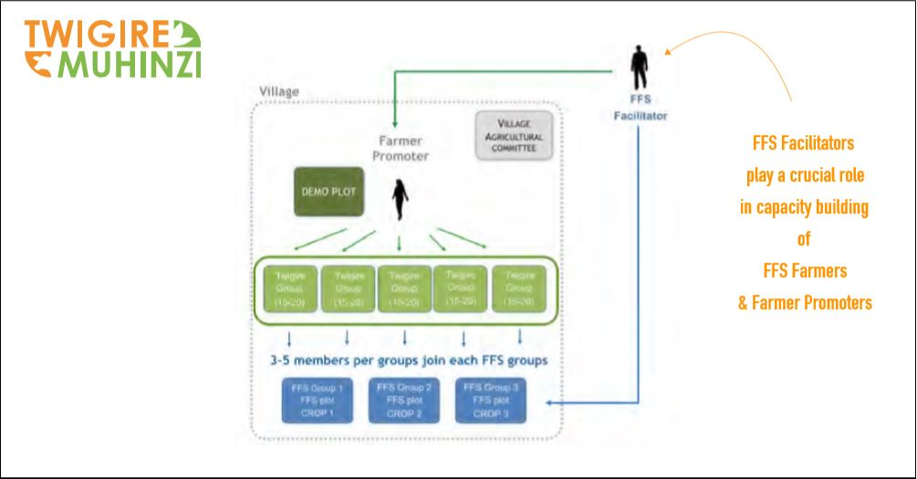

**Picture illustrating the role of FFS facilitators to both FFS farmers and FFS promoters (MINAGRI, 2016).**



**Picture illustrating a FFS Facilitator visits the demonstration plot established by a Farmer Promoter (MINAGRI, 2016).**

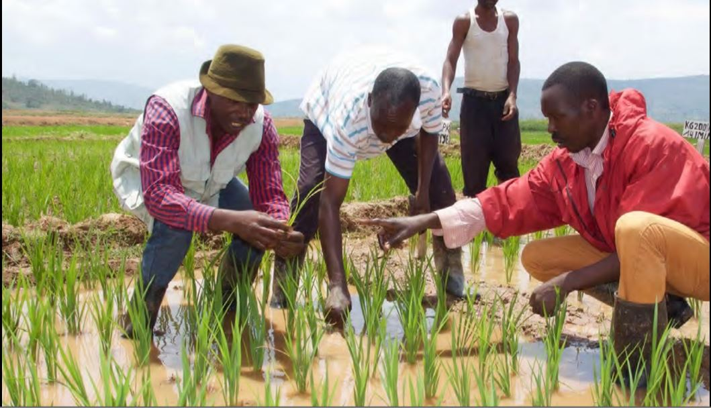

**Picture illustrating a group of FFS Farmers learning in the field. The plant is their teacher. They identified that this plant is not rice but weed! (MINAGRI, 2016).**

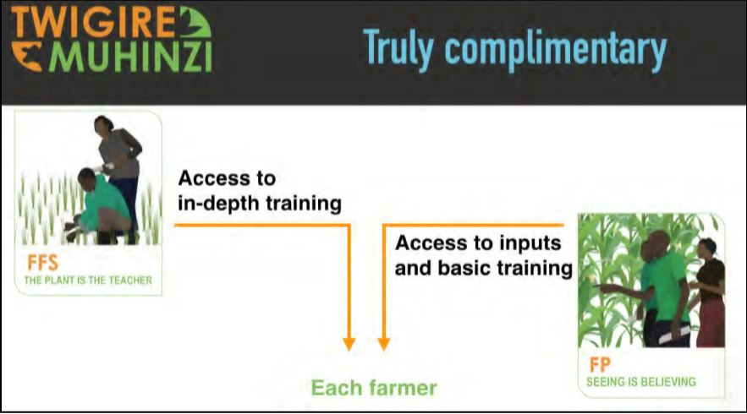

**Picture illustrating that each farm have access to all trainings provided by FFS facilitators where plant is the teacher, and to all inputs and basic trainings from farmer promoters where seeing is believing.**

**Examples COOPERATIVE KABOKU**

It deals with maize plantation (they are maize growers) at Kagitumba station near garden fresh ltd.

They have demo plots accordingly:

-Cropping patterns

-Fertilizers trials

-Seeds trials

-Pests and Diseases prevention

-Regular Crop phenology assessment and evaluation

**Farmer promoters:**

- Provide access to inputs combined with basic extension messages through mobilization and demonstration plots.

They ensure that cooperative KABOKU are included in the inputs requirement lists of the subsidy program of MINAGRI (CIP)

He/she collaborates with the agro dealers to ensure that requested subsidized inputs are in line with the guidelines and specific situation of cooperative (land size, crop, etc...)

Farmer promoters mobilize the farmers to consolidate land, plant in time and use the inputs appropriately.

They promote farmers to use both organic and inorganic fertilizers. An important tool to convince the farmers in cooperative KABOKU is the demonstration plots in which the farmer promotor shows the potential of using good inputs combined with agronomic practices

**Facilitators in KABOKU cooperative**

In KABOKU cooperative

- They organize farmers in FFS groups and facilitated by facilitators. Plant is the teacher and the plot is the school.

-Facilitators use FFS approach to build the skills and capacity of farmers to identify and analyze problems to conduct experiments aiming at developing local solutions appropriate at local specific challenges.

With the basis on the principle, “learning by doing” farmers truly develop their decision-making, skills, which helps them to handle current and future challenges effectively. Thus, farmers become progressively managers of their own economic activities.

**SUMMARY**

TWIGIRE MUHINZI is a homegrown solution for farmer to increase their yield and foster solidarity. It started in 2014 by Rwanda Agriculture Board in order to ensure that, all farmers in our country have access to advisory services, to solve the problem of food insecurity, and to reach on Millennium Development Goals. Therefore, the government of Rwanda had started TWIGIRE MUHINZI program as the solution those problem, which many farmers may face with simply by making field as **school** and plant as **teacher.** To achieve this, there are two approaches to meet their objective in agriculture extension, which are Farmer field school (FFS) facilitators and farmer promoters (FP). For easy decentralization and success of this extension, they interact with the farmers, scientistsand extension functionaries in Rwanda. By consequence, it make a quick and effective adoption and sustainable use of available updated knowledge, technologies and innovations in agriculture.

**CONCLUSION**

All farmers receive all of their requirements for their maximum productivity like agricultural inputs, technics and all other supports through approaches of TWIGIRE MUHINZI program. Thus, it is really a knowledge center for farmers.

**REFERENCES**

1. Wennink, B. & Mur, R. (2016), CAPITALIZATION OF THE EXPERIENCES WITH AND THE RESULTS OF THE TWIGIRE MUHINZI AGRICULTURAL EXTENSION MODEL IN RWANDA, (pdf).
2. Bizimungu, J. (2016), how farmer to farmer extension services model is transforming agri0sectors, the new times Rwanda’s leading daily, (pdf).
3. Rwanda Agriculture Board (2015), Twigire Muhinzi National extension system (pdf).
4. MINAGRI (2016), Farmer Field School Approach (FFS) &Farmer Promoter Approach (FP), TWIGIRE MUHINZI, reviewed at [www.twigire.com](http://www.twigire.com).