Military conquests and African resistances to colonization
BLOCK
10

Section 1: The Conquests

What are the main countries that conquered Africa?
⬧
Write your answer in the space provided below.

1.1 The French conquests
The French most rapidly made themselves famous in military conquests.
Keywords

Conquests
Military expedition
On July 5, 1830, an expedition led by General de Bourmont seized Algiers, the Algerian capital. The reaction of the native peoples was relentless opposition vis-à-vis the Christian Frenchmen. The French governors were sent in Algeria with a mission to just guard the territory because France did not want to invest in Algeria. French opinion estimated that this adventure was expensive and without interest. This conquest of Algeria by the French was going to find expression in colonization. On December 29, 1840, France appointed General Robert Bugeaud as the Governor General of Algeria who, on his arrival in Algiers declared to the soldiers: “it is not enough to vanquish the enemy, you must subject him”. And to the settlers: “The conquest of Algeria must be done by the sword and the plough”.
Tunisia, a country neighbouring Algeria, remained free from French attacks for a long time. The plundering incursions which Tunisians did in Algeria triggered a French counter-attack of April 24, 1884 under the commandment of General Forgemol. On May 12, 1881, the Bardo treaty establishing French protectorate in Tunisia was signed. This treaty was saying: “The French presence will never cease to have the character of a permanent and liberal aid”.
- The conquest of Morocco started on May 24, 1912 when a French military expedition arrived in Fez under the commandment of General Lyautey who, after, will be appointed the Commissioner General of the French Republic in Morocco.
The conquest of the Sahara began starting from Algeria, and France put many years to subject it. In 1881, the Touaregs, made fanatic by Moslems had massacred in the Hoggar, one mission headed by Fratters. In 1889, the whole of the North-West part was conquered. The Touaregs’ Hoggar was occupied only in 1902.
In North Africa, French possessions, less rich than those of the British, were much more gathered together: the French possessed only a very little territory in East Africa, the Coast of the Somalies. Their conquests were centered over the Sahara desert.
In 1914, they possessed the whole of North Africa: Algeria, conquered since 1830; Tunisia, to which they had imposed a protectorate in 1881; finally Morocco which became a French protectorate in 1912. From 1898 up to 1902, the Sahara desert had passed under French control. They had also established their linkages with the possessions they had acquired in Black Africa.
- In the Senegalese basin, the French began by conquering the Kajoor Kingdom, which fell in 1866. The following year, they destroyed the Soninke Empire in Senegambia. In 1898, after a long fight, Chief Ahmadu, the son and successor of El Hadj Omar was vanquished and thus the Tukuloor Empire of Segu disappeared.
- In the Guinea Gulf, the French conquered Ivory Coast and Guinea in 1893. The same year, it was the entry of French troops in Dahomey and the deportation of King Behanzin.
- In the Basin of Niger, the French clashed with the determination of the Moslem chief Samory Touré who was captured in 1898 and was exiled in Gabon in 1900. In 1894, French soldiers have been able to take Tombuktu and once the masters of Upper and Mid Niger, they made the junction between the inside of the territory and the coast.
- In Central Africa, Gabon was conquered in 1890 and between1898
- and in 1899, an expedition led by Captain Lamy occupied Chad and the Ubagui-Chari.
- In Madagascar, it is towards 1880 that the commercial and
- diplomatic influence of the French affected the unity of Madagascar. In 1885, the French got a treaty signed making of this country their protectorate.
- In 1895, a military expedition entered Antananarivo, deposed the Prime Minister and caused a rebellion which spread all over the island. General Galliéni started from West Africa in order to conquer and “pacify” Madagascar which was declared the French colony. Queen Ranavalona III was exiled in Algiers in 1897.

1.2 British conquests

- In the Gold Coast, the British conquered the Ashanti Kingdom after the capture of Kumasi in 1890. King Nana Prempeh was exiled in the Seychelles.
- In Nigeria, the complete British conquest over the Yoruba
Kingdom had been done since 1893. They had more difficulties in the East, in the Ibo territory which surrendered only in 1910
In North, the Sokoto Sultanate was conquered in 1902 by, Frederick Lugard.
- In Eastern Africa, Zanzibar became a British protectorate from 1890 and served as a rear base to conquer the rest of East Africa. In Uganda, resistance was broken down only in 1899 when Mwanga, the Kabaka of Buganda, and Kabarega, the Mukama of Bunyoro were captured and exiled in the Seychelles.
In Kenya, the British had difficulties also in subjecting the populations, especially the Nandi in 1895
- In South Rhodesia, the Cecil Rhodes’s British South Africa company occupied the Mashonaland and forced King Lobenguela to flee away in 1893. The resistance of Shona and Ndebele was terminated only in 1897 after a bloody repression. In Northern Rhodesia, the conquest became easier and was completed in 1901.
- In the North of Africa, the British had ended by establishing their domination in Egypt. Masters of Madhist insurrection in Sudan, the British had imposed a disquised protectorate to Egypt as well as to Sudan and the protectorate had been baptized ’Anglo-Egyptian’ condominium in 1899

1.3 The German conquests
- In South-West Africa, the Germans became able to quickly impose themselves at the end of the 19th century by exploiting the rivalries between the Nama and the Herero tribe.
- In Togo, they used the same method of opposing the populations against each other and thus became able to crash the Konkomba tribe in 1898 and the Kabres in 1890.
- In East Africa, the conquest was longer and more difficult, due to the resistance of Abushiri (1888/89) and the maji maji revolt (1905/1907)

1.4 The Belgian and the Portuguese conquests
From 1891 up to 1895, the officials of Leopold II had not an easy task to military occupy the Independent State of the Congo. The Belgians first made friends with the Arabs of Eastern Congo, notably Tippo-Tip, but their good understanding was did not last longer, because their interests were diverging. The Independent State of the Congo attacked the Arabs who resisted during three years, from 1892 to 1895. The occupation of Katanga was achieved only in the beginning of the 20th century.
The Portuguese military conquest was not easy at all. Having begun a bit after the Conference of Berlin, it was completed only late at the end of the 19th century in Angola, in Mozambique and in Guinea Bissau.

1.5 The reasons of the rapidity of European conquests
- More and more advanced knowledge of Africa. Thanks to the writings of missionaries and explorers, European countries were well informed about the physical aspect, the strengths and the weaknesses of States and African societies
- The progress of medicine. Thanks to the discovery and to the use of quinine against malaria, Europeans were less and less afraid of the African continent.
- Material and financial resources. Europe had more means than African States to sustain long and expensive wars.
- African competitions. At the time of the European conquests, Africa was involved in interethnic fights (Ashanti against Fanti in the Gold Coast, Baganda against Banyoro in Uganda, Shona against Ndebele in South-Rhodesia) which prevented it to lead coordinated actions against a well organized adversary.
- European military superiority. The more determinant factor was the logistic and military superiority of Europe. Whereas this continent employed professional and well-trained armies, few African States had standing armies. African armies used spears, arcs and old rifles, whereas Europeans had of modern weapons, heavy artillery and especially machine-guns. These ones were developed by engineer Maxim from 1880. They quickly proved to be formidable weapons’ The two African chiefs who could inflict some defeats to Europeans are Samory and Ménélik II of Ethiopia, because they had been able to get modern rifles.
In conclusion, as it can be noted, about 1900, except for Liberia and Ethiopia, all Africa was in the hands of the European States. At the beginning of the 20th century, the conquest was almost completed. The history of this one was written in the blood of many Africans. But although the conquest of Africa was relatively easy, its effective occupation proved to be more delicate, because the resistance of Africans was going to continue in several forms during several years.
Activity 1

Who are the military chiefs that contributed to the conquest of Northern Africa?
Name some ethnic groups which were involved in fighting at the time of European conquests

Feedback
Compare your answers with those proposed at the end of the module. If you did not find good answers, please review the section.

Section 2: African resistances

Where did Africans resist most against colonisation?
⬧
Write your answer in the space provided below.

In spite of the technological and financial superiority of Europe, in spite of bloody repression by occupation armies, Africans actually did not resign themselves to the European domination. Contrary to the opinion spread by colonialist literature, Africa was not a continent where reigned anarchy, brutality, ignorance and misery. African nationalism was always expressed without interruption and in varied forms until the recovery of independence. When one looks at this very closely, a majority of leaders chose the defense of their sovereignty and their independence. It is in their strategies and the techniques, which they adopted to attain their objectives that the differences appear.

2.1 Northern Africa

Egypt
The bad financial management of Khedive Ismael (1863-1879) and Tiwfik (1879-1892), his successor, impoverished the population and the country and provoked a great dissatisfaction. The direct and principal cause of the starting up of revolt was the feeling of the frustration of badly paid, ill-treated and despised Egyptian militaries. Led by Colonel Ahmad Urabi, the Egyptian revolution was a success in the start: an Arab cabinet was formed and Urabi appointed the Minister for Defense.
Keywords

Resistance
Jihad
Guerilla
The British reaction against this revolution was severe and deadly, in spite of the courageous resistance of the army and the Egyptian people. After this defeat, Urabi declared the jihad against the British and mobilized all the Egyptians who took part in the resistance financially and militarily. But the British troops commanded by Sir Garnet Wolseley crashed Egyptians at the battle of Tell al-Kébir, on 13, September 1882.

Sudan
At the start, the majority of the Sudanese peacefully expressed their hostility towards the British by continuing to read the Madhist prayer book and practice various Madhist rituals. Only a handful of partisans of the Madhi, on many occasions, tried to forcefully drive out the “infidels”. Also, uprisings took place in February 1900, in 1903 and in 1904.
But the most important of these uprisings were organized and led by a renowned Madhist, Abd al-Kadir Muammad Iman, generally called Wad Habuba. For having preached Madhism and challenged administration, troops were sent to catch him. Notwithstanding fierce fighting, the rebellion was come over, and Wad was arrested and executed in public on the 15 May 1908.

2.2 Eastern Africa

Kenya
The Nandi people in the North- West of Lake Victoria opposed the longest and wildest resistance against the British occupation to Kenya. It lasted, from 1890 to 1905, until the death of their leader killed while fighting, following treason. This is explained by the nature of the society characterized by supra clan cohesion. The society was divided into territorial units and each one of them had its warriors responsible for the defense of the territory. Contrary to neighboring peoples, it is the territory and not the clan, which was the center of social life with the Nandi. This consequently, excluded clan competitions and ensured them a military superiority in the region.
The British conquest found in front of it a dynamic society in full political and economic expansion, and evolving toward a centralized State. The bravery of the Nandi warriors and the cohesion of the society enabled them to resist for six years.
At the time of the settlement of the British in Kenya, Waiyaki, the chief of the Gikuyu, allowed Frederick Lugard, an official of the British East Africa Company, to build a fortress on his territory. He even concluded a blood pact with the British. But later on, when his request for possession of firearms was rejected, he attacked the headquarters of the company in Dagoretti. A few months afterwards, he changed tactic and rallied with the British to be maintained in power, but was deported nevertheless. This shows that many Africans changed tactic according to circumstances in view of the forces in presence.
On the coast of Indian Ocean, the Mazrui family protested. Led by Mbaruk Bin Rashid, resistance to the British forces required the request of the Indian troops. The head of the resistance fled to Tanganyika, but was captured by the Germans.

Uganda
Between 1891 and 1899, there were several engagements between the forces of Mukama Kabarega in Bunyoro and Frederick Lugard. When the latter was overcome, he resorted to diplomacy. He tried to get along with Lugard but in vain. Kabarega then engaged in guerrilla. He evacuated Bunyoro and withdrew to the North, in the Lango country, a place from which he harassed the British forces. Kabaka Mwanga joined him in his refuge which finally was discovered and destroyed in 1899. The two monarchs were captured and exiled in the Seychelles.
When Kabaka Mwanga in Buganda was enthroned in 1884, he was wary of missionaries who had succeeded in making contacts with the population. The Baganda who had converted to Christianity and who had refused to obey his orders were put to death. His diplomatic skills appeared in the manner in which he exploited the competitions between the different religious confessions. Sometimes he was an ally of Protestants and Catholics against Moslems, sometimes he collaborated with Protestants and Catholics whom he considered dangerous for him.
In 1885, he tried to attract all the foreigners and their Baganda partisans on a naval parade in an island of Lake Victoria. He wanted to make them die from hunger on this island. His plan was discovered and the British deposed him and replaced him by his brother. In 1899, Mwanga tried to take the power again, but was exiled the same year.
There were as many Baganda in the resistance as there were collaborators who contributed to the British expansion, such as General Kakunguru who is at the basis of the extension of the British power to the North and the East of Uganda. It is him who captured Kabarega and gave him back to the British.
The agreement of 1900 made the Baganda the partners of the British in the extension of the British power in all Uganda. Many colonial administrators in the North, East and West were Baganda. The hatred of colonialism was turned more on the latter than on the British themselves. This is at the basis of the political problems that Uganda was going to face after Independence.

Tanganyika territory
Mkwawa, chief of Bahehe in the South-West of Tanganyika revolted against the Germans in 1891. This tribe inflicted a severe defeat to a German army strong of 1.000 men. In 1894, the Germans counteracted and after hard combats took the Kalinga capital. Mkwawa continued the guerrilla, but seeing that he was encircled by the Germans, he committed suicide. His head was sliced and sent to Germany. In 1954, it was returned at the request of the Bahehe tribe.
For a long time, there existed on the coast of the Indian Ocean an Afro-Arabic population with very mixed blood which dealt mainly with trade. The arrival of the Germans threatened their interests. Resistance was organized by Abushiri, an Arab with a mother from the Oromo tribe. In 1888, its troops set fire to a German warfire ship in Tanga. They attacked Kilwa, killed two Germans and took assault of Bagamoyo. In 1889, the Germans sent reinforcements under the control of Herman Von Wissmann who obliged Abushiri to flee away. Having taken refuge in the North, he was betrayed and delivered to the Germans who hung him in Pangani on December 5, 1889. The town of Kilwa was bombarded, then taken by the Germans in 1890.
Between 1905 and 1907, the Maji-maji uprising was indisputably the most significant challenge launched against German colonialism in Eastern Africa. The immediate cause of the revolt is the obligatory cropping of cotton which made it that the populations were forced to forsake their food crops. Moreover, the workers received poor wages. The leader of the movement, Kinjikitile Ngwale, whose residence was in Ngarambe, told the populations that an uprising had been ordered by God. To reassure the combatants, he prepared magic water (maji) which was to transform into water the German bullets and make invulnerable the partisans who would drink some of it. The movement lasted for two years, from July 1905 to August 1907, was extended on a zone of almost 26.000 km² and gathered more than 20 ethnic groups. Germany, caught off its guard, gathered a large army which burned all on its passage. The leader of the movement was hung on August 4, 1907. The uprising ended with a massacre which made more than 120.000 dead.

Burundi
While Oscar Baumann, a German explorer, was touring to the source of the Ruvubu River, on the Congo-Nile foothills, he collided with the first resistances. He was attacked by a group of two hundred men armed with arcs and spears. But Baumann with his askaris beat them without any resistance, Burundians deplored many dead while Baumann deplored only the loss of one single Masai interpreter. After some days, when he had established his camping near the source of the Ruvubu, he had to drive back many attacks. But when he arrived inside the country heading South, he had to endure another very violent attack in the course of which Burundians deplored a lot of human losses

Rwanda
In spite of the interdiction of Rwabugiri according to which Rwandans ought not to fight Europeans but search for their friendship because they were military very strong, some people transgressed this interdiction and led an attack against the Belgians at Shangi in July 1896. As soon as the combat was engaged on both sides, Rwandans were killed in great numbers and there was a save your souls

2.3 Central Africa
African reactions in this part of the continent can be classified in three categories: those which attempted to preserve the local societies, those which wanted to fight the abuses of the colonial system and the rebellions which wanted to drive out the Europeans.
In Belgian Congo, the revolts were very frequent and localized a little everywhere, but some of them remained famous. Tippo Tip disputed the area of Upper Congo with the Belgians. The Bayaka tribe fought Europeans during more than one decade before capitulating in 1906. King Msiri opposed a great resistance in Katanga before being subjected.
In this Angola, it is worth mentioning the resistance of the Humbe and Cuamato which pushed back several attacks by the Portuguese in the beginning of the 19th century.
- In Nyasaland, the resistance was led by a priest of the Tonga ethnic group, called Malama. In 1909, he invited the populations to expel the whites:“the day has just come to fight the white men. Let us start today and let us fight during the whole rainy season. Let the black people stand up! And let them drive the Whites out of this territory”.
- In Mozambique, in the valley of the Zambezi River, the Shona religious heads incited the populations to support the rebellions which they organized between 1897 and 1904. They said that the drought, the famines and the diseases which devastated the country at that time would disappear only with the departure of European invaders.

2.4 Southern Africa

The Zulus and the Ndebele tribesmen
During the conference of Berlin, South Africa counted four political entities: the Cape colony, Natal, the free Orange State and Transvaal. The white minorities were conscious that African masses were to be subjected.
Following a minor incident between Natal and Cetshwayo, the king of the Zulus, the British army invaded the country on January 11, 1879. In spite of a strong resistance at Isandhlwana battle, Cetshwayo was exiled in Cape Town and his nation divided into 13 chieftainships headed by weak men.
In Matabeleland and Mashonaland, the son of the famous Protestant missionary Moffat convinced King Lobenguela, the son of Msilikazi, to rally with the British rather than with Afrikaners, Portuguese or Germans. On February 1, 1888, he signed a convention which subjected him to British colonialism. Having noted that he had been deceived, he wanted to resist militarily, but in vain. After his death towards 1890, the Ndebele nation broke up.

The Sotho, Tswana and Swazi
Contrary to the Zulus and the Ndebele, these three people had been able to tie good relationship with Protestant Missionaries, in particular Mac Kenzie, who did everything to transform their countries into protectorates. Although they were militarily weak in comparison with the great states which were invaded and then dismembered, these people were treated relatively better.

The Herero
In 1904, some Herero protesting against the German domination in South-Western Africa massacred a hundred Germans. Repression was wild. General Von Trotha organized a veritable genocide: 75 to 80% of the Herero population, this is approximately 80,000 people were killed.

2.5 Western Africa

French West Africa
The French were established in Senegal since 1854. In 1879, the Governor of this colony asked the Damel Latjor of Kajoor the authorization to build a road connecting Dakar to Saint-Louis. When he learned that it was about a railway, he opposed this project and mobilized his subjects. He died with his weapons in his hands on October 27, 1886.
During the French conquest, the Tukulor Empire was in the hands of Ahmadu, son and successor of El Hadj Omar. He was not politically at ease since he was fighting on three fronts: against his brothers who rejected his authority, against his subjects (Bambara, Manding and Peuls) not yet completely subjected and against the French. He initially chose the diplomatic way against the French. But facing Archinard’s quarrelsome attitude, he later on chose the military way. He was beaten on December 23, 1890.
In this region, the most important resistant was Samory Touré.
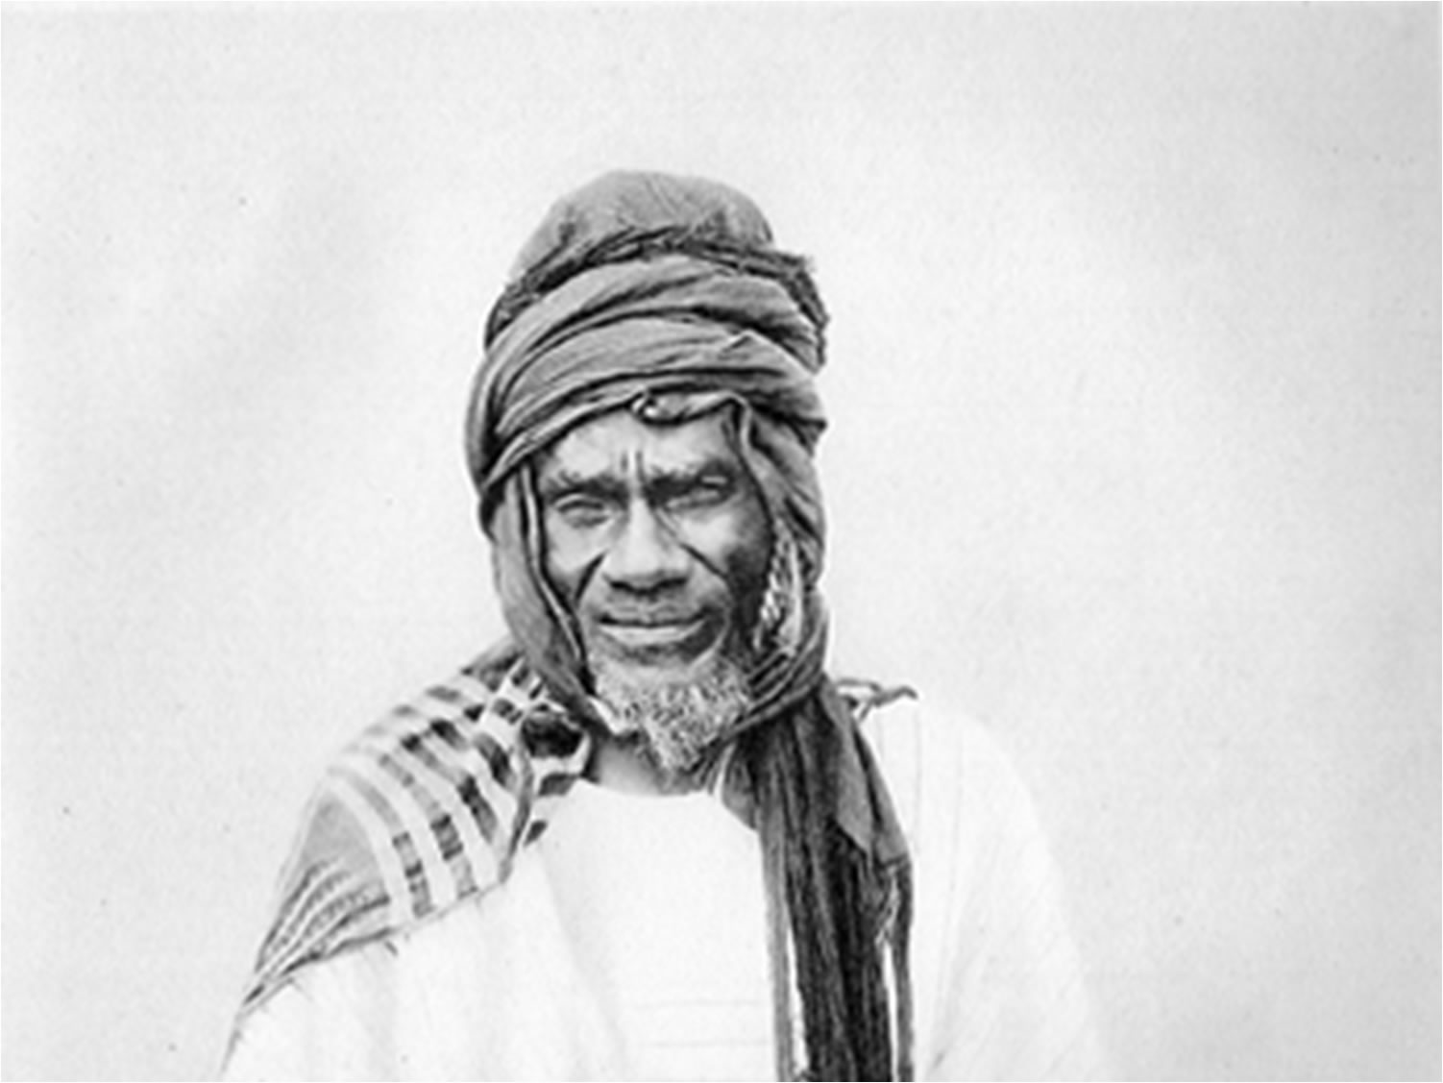
The empire that he headed towards 1880 was situated in the North of Sierra Leone and present Ivory Coast. On arrival of the French, he had constituted an army equipped with modern weapons, which totalized 35.000 soldiers in the infantry and 3.000 in the cavalry. Archinard who had just seized the Tukuloor Empire attacked Samori in 1891. The engagements between the French and this resistant lasted for a long time.

Samory Touré

He was finally made a prisoner on 29th September 1898 and was exiled in Gabon where he died two years later.
In Dahomey, at the time of the French conquest,King Béhanzin had a standing army of 4,000 men and women, the Amazones, fearsome warriors. The negotiations to let the French settle not being likely to succeed, there was confrontation and Behanzin was arrested on January 29, 1894.

British West Africa
The confrontation between the British and the Ashanti lasted about sixty years, between 1760 and 1824. Ashanti initially beat the British and occupied the coastal states of the Gold Coast. The British, then equipped with modern weapons, pushed back the Ashanti and destroyed Kumasi in 1874. This defeat caused the collapse of the Ashanti and destroyed Empire. The asantahene Prempeh succeeded in reconstituting it.
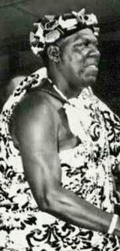
The British proposed to the Ashanti to place them under protectorate and to install a Resident in Kumasi. Prempeh refused politely and sent a diplomatic mission of 300 people to the Queen of England to explain this attitude to her. It arrived there on April 3, 1896, but they refused to receive it. The British took Kumasi by storm in January 1896. Prempeh had chosen not to fight them. He, his family and his military chiefs were nevertheless arrested and deported to the Seychelles in 1900. In the Yoruba countries, since 1884, the British had been able to sign treaties with local chiefs proposing the abolition of slavery, the development of trade and the introduction of a protectorate.

Asantahene Prempeh
Ijebu was the only Yoruba State to refuse the settlement of missionaries, the British tradesmen and the colonial administration. During a military confrontation in 1892, it was beaten in spite of the resistance of its army strong of 10.000 men.
The conquest of the North of the emirates of Northern Nigeria was carried out by the National African Company. The emirates of Nupe and Ilorin were the first to be invaded in 1897. The emirs of Amadua, Bauchi, Kano and Sokoto had to surrender between 1900 and 1903, after having fought valiantly against the British.

2.6 Madagascar
Towards 1880, the Merina Kingdom was subject to French pressure on the commercial and diplomatic plans. Prime Minister Rainilairivony did not willingly admit the treaty making Madagascar a French protectorate. In 1894, France sent a military expedition to Madagascar which penetrated into Antananarivo and ousted the Prime Minister. Insurrections burst everywhere in the island.
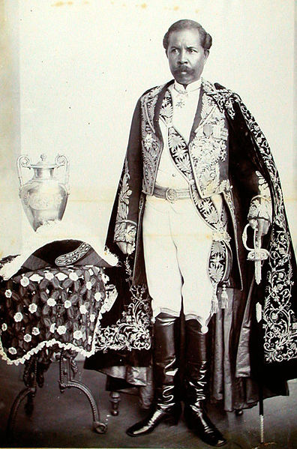
The Christians were pursued. In 1895, General Galliéni left Western Africa to pacify the country, which was declared a French colony. It took more than nine years for all the Malagasy people to accept French domination. The last Queen of Madagascar was exiled in Algiers in 1897.

Prime Minister Rainilairivony

Activity 2
Identify the reasons which pushed the Africans to resist against colonisation
How did the Africans react to the European invasion?

Feedback
Compare your answers with those proposed at the end of the module. If you did not find good answers, please review the section.

Block summary
We can conclude that the British, the French, the Belgians and the Portuguese quickly conquered the African continent because of their military superiority and their financial capacity, but also because of inter ethnic conflicts between Africans. Nevertheless, all whole Africa tried to resist, but in vain. The main leaders of the resistance were either killed, or arrested and exiled.

Answers to activities in this block


Activity 1
- General Bourmont and General Bugeaud in Algeria, Forgemol in Tunisia and Lyautey in Morocco
- Ashanti against Fanti in the Gold Coast, Baganda against Banyoro in Uganda, Shona against Ndebele in South-Rhodesia

Activity 2
- Economic reasons (taxes, poor salaries for workers); political reasons (sovereignty); religious convictions; frustration, etc.
- Most of them resisted militarily, but others negotiated

